**Data Visualisation in Python**

Table of Contents

1. Data Visualisation in Python 2

1.1. Visualisations with *Matplotlib* 2

1.2. Common Plots in *Matplotlib* 10

1.3. Customising Plots in *Matplotlib* 13

1.4. Recommended resources for further reading on *Matplotlib* 17

1.5. Visualisation with *Pandas* 17

1.6. Visualisation with *Seaborn* 23

1.7. Facet Grids and Matrix Plots in *Seaborn* 53

1.8. Summary 56

1. **Data Visualisation in Python**

*Written by Liping Zheng.*

As we covered in the Big Data, Analytics and Visualisation (BDAV) lecture, data visualisation is the graphical representation of information and data, which can be applied to remove the noise from data, find out the pattern and trend and highlight the useful information to tell stories. Data visualisation can be used for data exploration to help us understand data and quickly get some initial insight from big amount of data or be used to present data analysis result to facilitate decision making. We have been using Tableau to do data visualisation, and here we are going to introduce how we can visualise data using Python.

Python is powerful in terms of data visualisation since it offers multiple great visualisation libraries with different features to fulfil your needs. There are some popular and commonly used plotting libraries in Python, including *Matplotlib*, *Seaborn*, *ggplot*, built-in visualisation in *Pandas* and *Plotly* (among others). In this section, we will introduce *Matplotlib*, *Pandas* visualisation and *Seaborn* (arguably the most commonly used in the data science community).

* 1. **Visualisations with *Matplotlib***

*Matplotlib* is the most popular plotting library in Python. It’s originally created by John D. Hunter and has become an active developer community. It provides MATLAB like interface so you might feel natural with *Matplotlib* if you are familiar with MATLAB. *Matplotlib* is an excellent library for both 2D and 3D graphical plotting, and it allows to create animated and interactive visualisation as well. Here we will introduce some basic examples using *Matplotlib*, and I strongly recommend you to explore the *Matplotlib* official webpage (<http://matplotlib.org/>).

*Matplotlib* is included as standard in the Anaconda distribution. Should you be using another flavour or Python you will need to install the library:

pip install matplotlib

After the installation, you need to import the *pyplot* module, which is conventionally done using the name *plt*:

import matplotlib.pyplot as plt

You'll also need to use this line to see plots in the Jupyter notebook:

%matplotlib inline

*Note, this line is only used for Jupyter Notebooked or other products such as the Jupyter QT Console. If you are using other editor, you’ll just use plt.show() at the end of all your plotting commands to have the figure pop up in another window.*

Next let’s see some simple examples and be familiar with some basic commands of *Matplotlib*. Like many other plotting libraries or languages, *matplotlib.pyplot* module allows to perform the plot directly without explicitly creating an axe. For example, you can create two list as x and y in an axe and graph them directly with plt.plot() as shown in **Figure 130**.

plt.plot([1, 2, 3, 4], [1, 4, 2, 3])

***Figure 130: Simple example of visualisation using plt.plot( )***

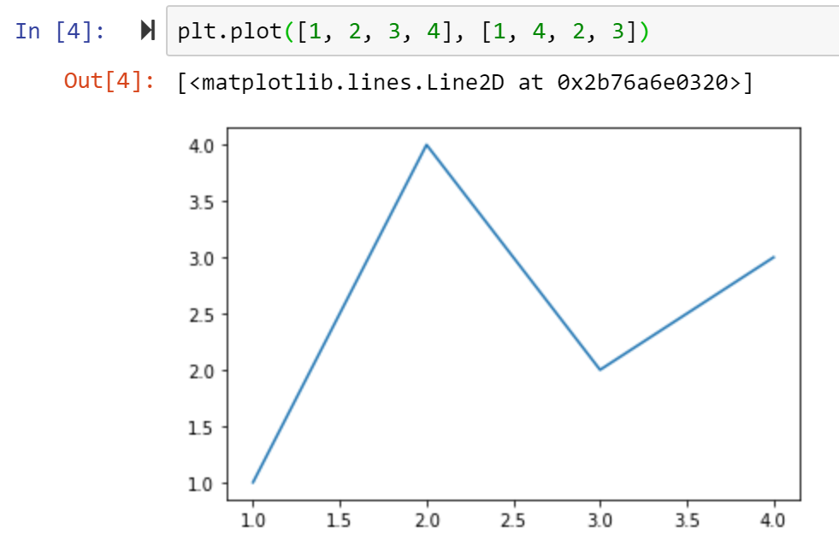

The above is showing one of the approaches to use *Matplotlib*. This approach relies on *pyplot* to automatically create and manage the figures and axes and use *pyplot* functions for plotting. You can set up colour for the plot, as well as the axis labels and title. This is demonstrated in **Figure 131**.

***Figure 131: Formatting the plot***

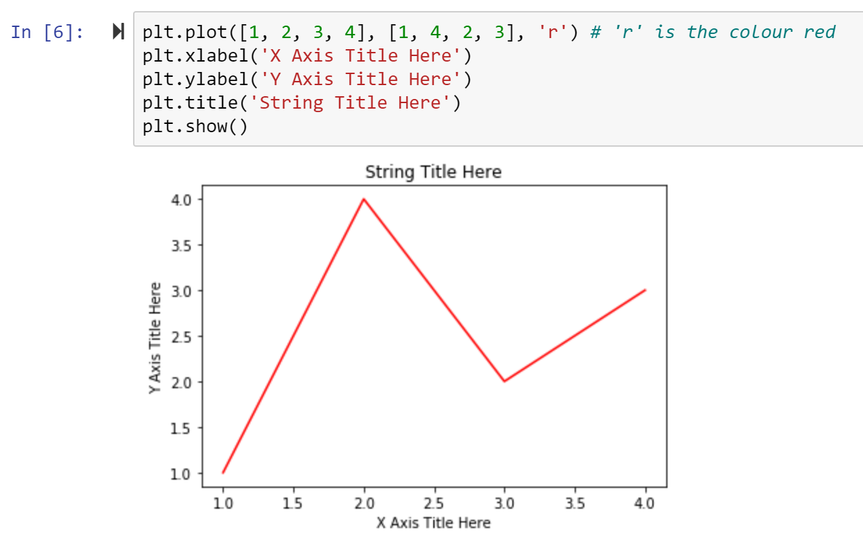

You can also create multi-plots on the same canvas by either using *plt.subplot()* to create two plots in grid or using *plt.plot()* sequentially with different data to create combo plot. This is shown in **Figure 132** and **Figure 133**.

***Figure 132: Multi-plotting example #1***

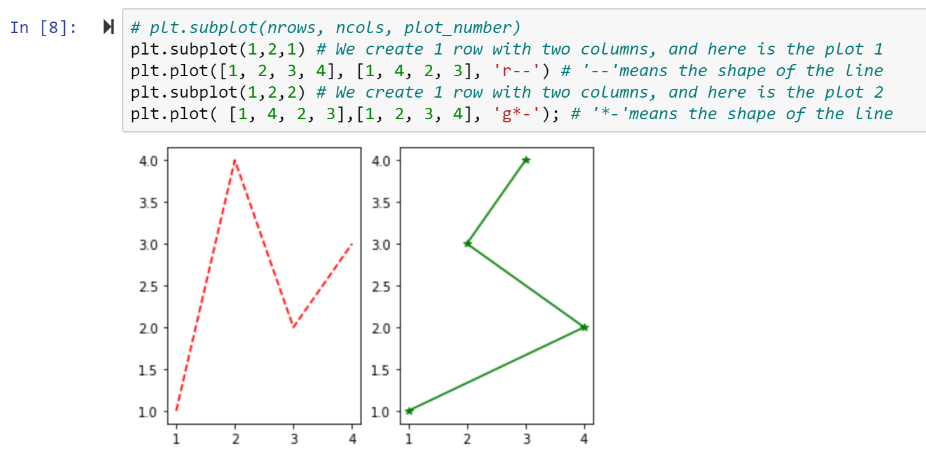

***Figure 133: Multi-plotting example #2***

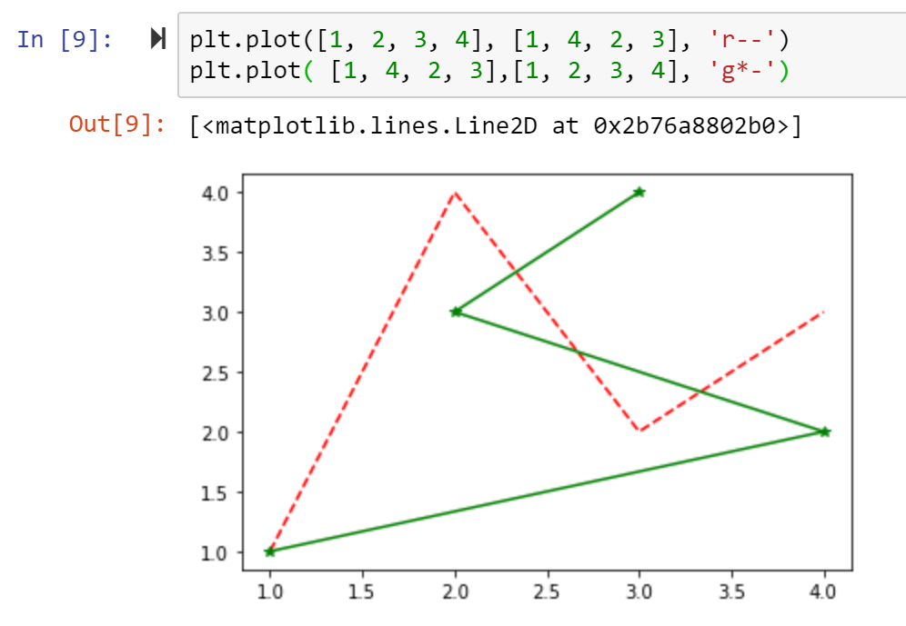

There is another way to use *Matplotlib* by explicitly creating figures and axes and call methods on them. This is what we would commonly call an object-oriented approach. In the practice, this method is more commonly used since this is nicer when dealing with a canvas that has multiple plots on it.

Generally, *Matplotlib* graphs your data on figure(s), each of which can contain one or more Axes. The simplest way to create a figure with an axe is using *plt.subplots()* and then use *ax.plot()* to draw some data on the axes. The above example can be also written by this way with the same output:

***Figure 134: Create figures and axes using an object-orientated approach***

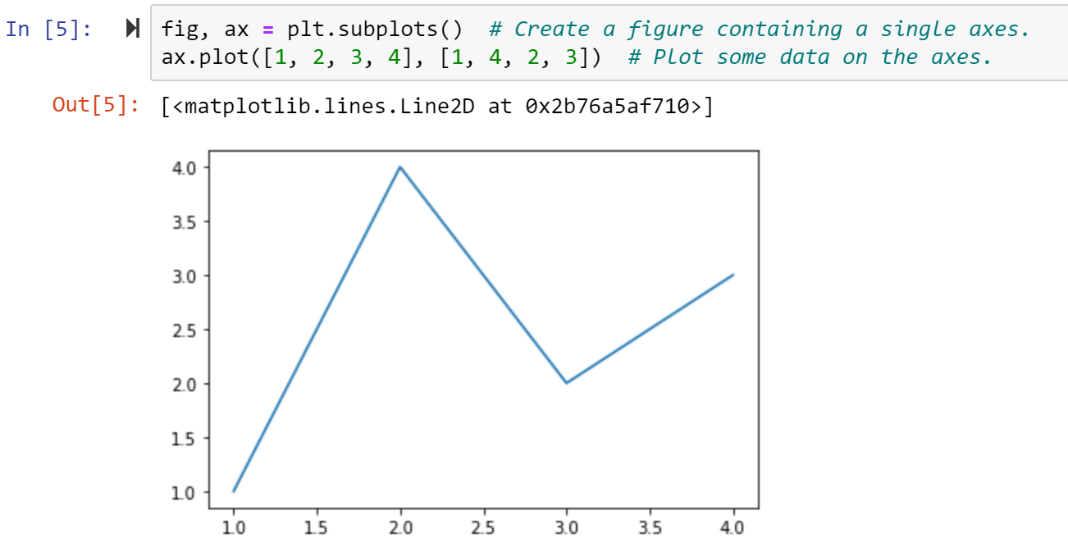

You can also create multi-plots in this object-orientated approach:

***Figure 135: Creating multi-plots using an object-orientated approach***

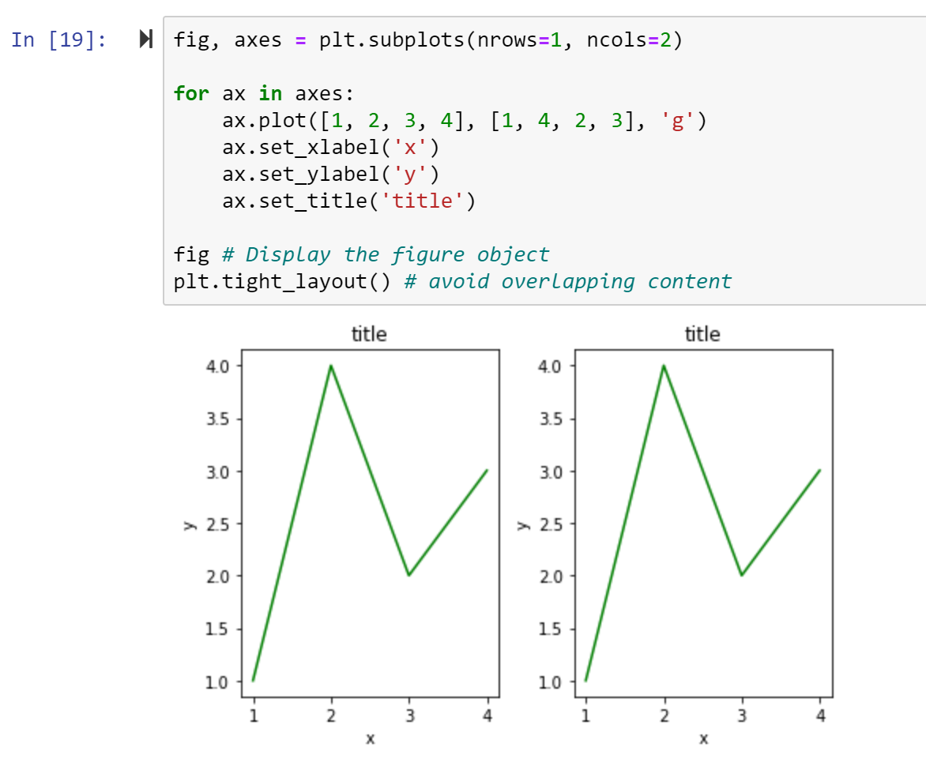

Another (more useful!) variant on this would be to use different data on each plot, as shown in **Figure 136**.

***Figure 136: Creating multi-plot figures with different data***

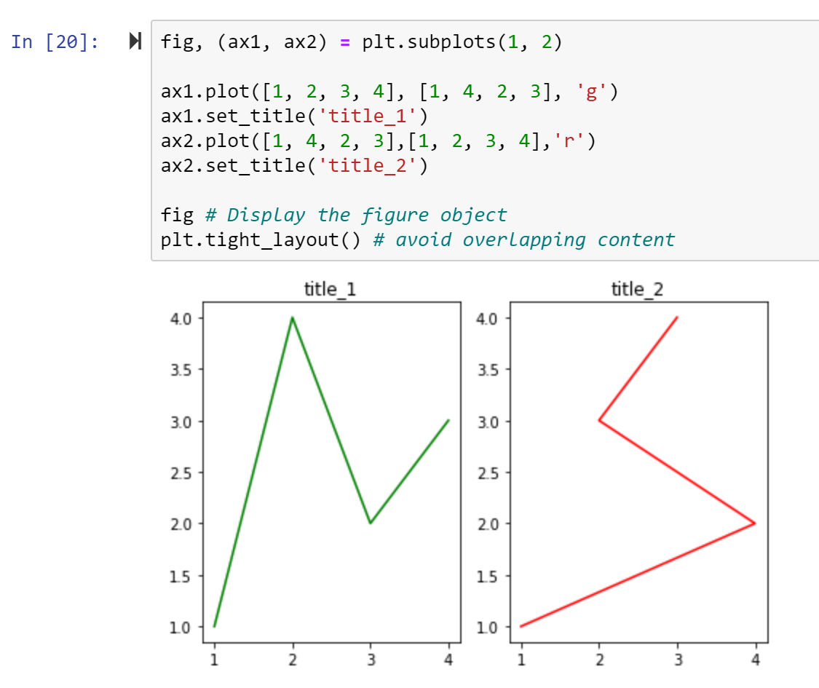

We can also create a single figure with both sets of data (using the same axes):

***Figure 137: Creating a figure with two datasets on the same axes***

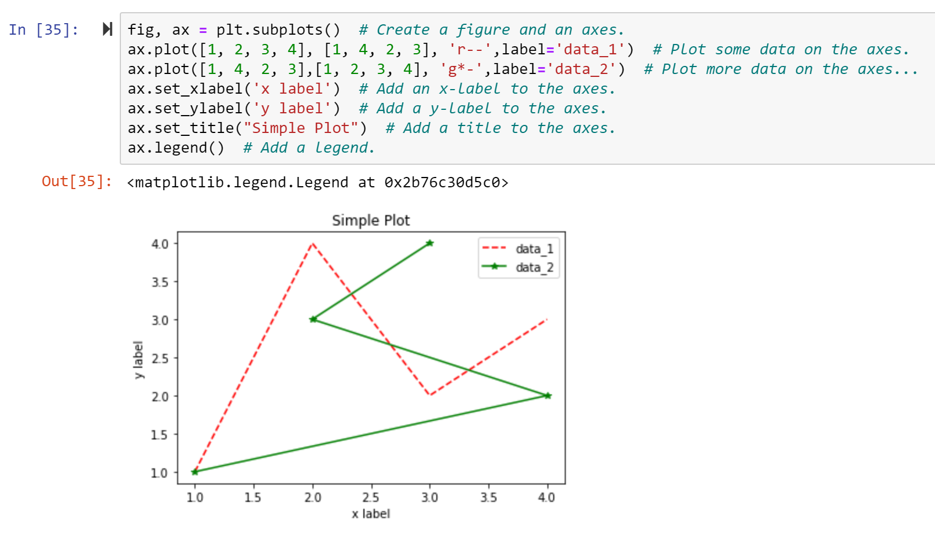

It is typically more convenient to create the axes at the same time as the figure, but they can also be added later in the code, allowing for more complex axes and layouts:

***Figure 138: Creating figures and axes separately***

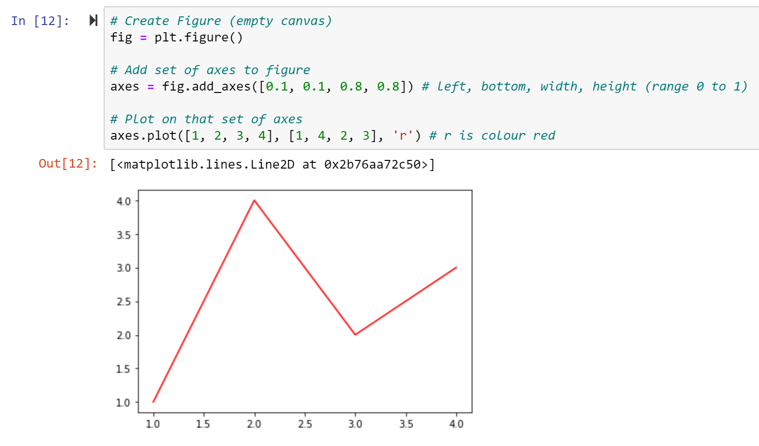

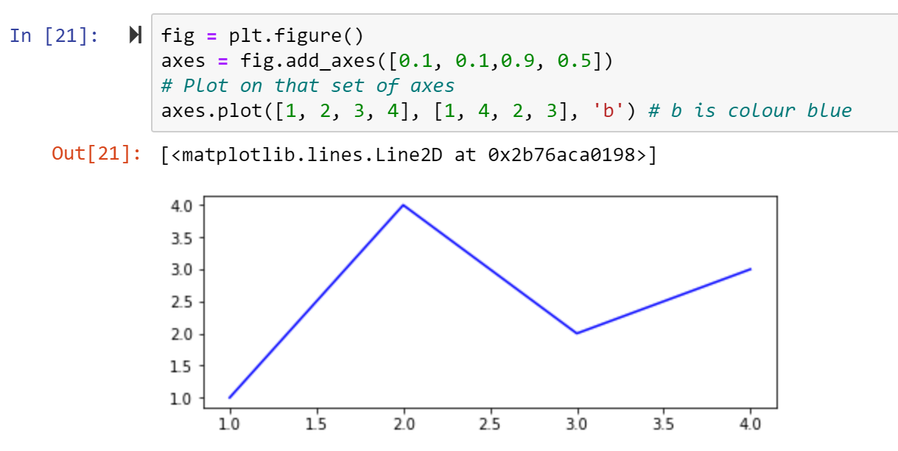

We can plot axes inside other axes (e.g. a chart inside a chart) as shown in **Figure 139**.

***Figure 139: Inserting an axes inside an axes***

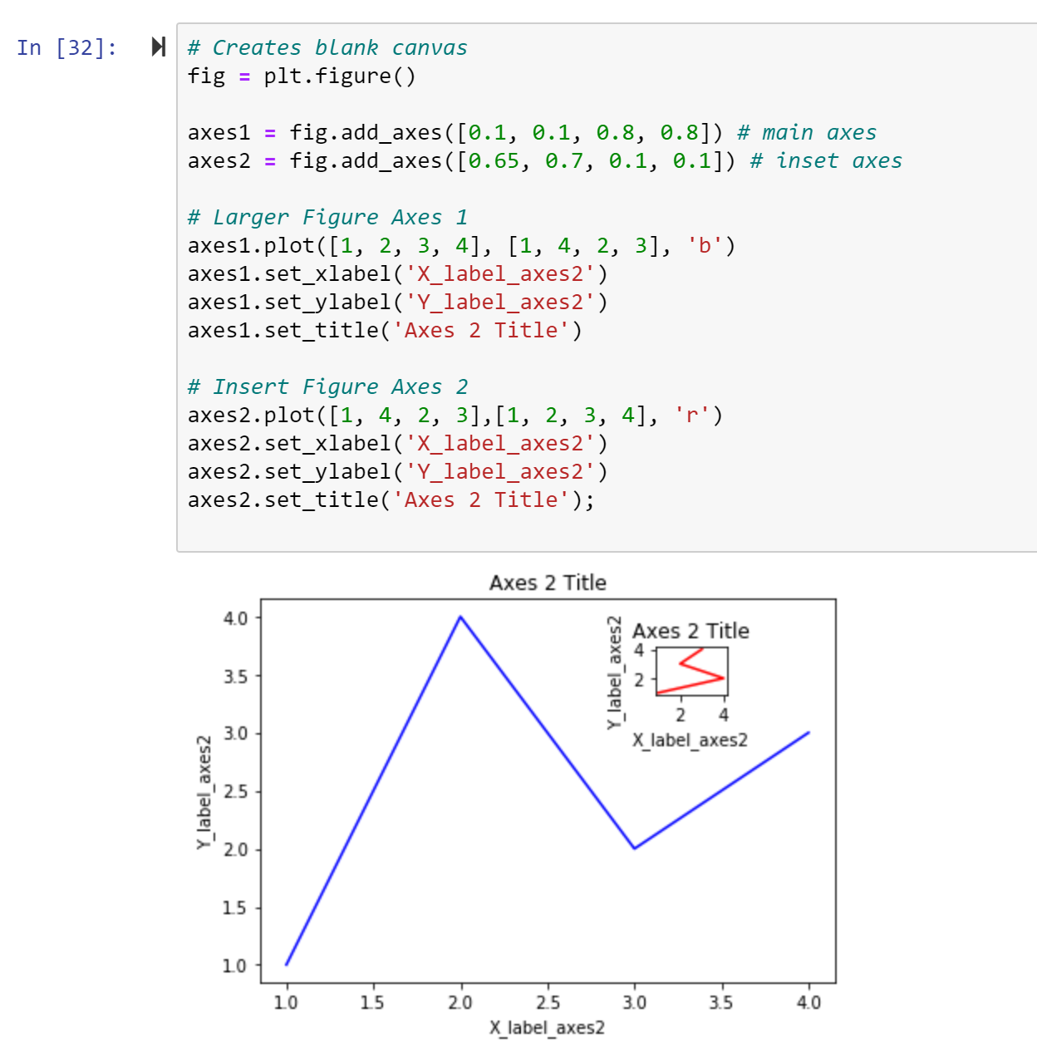

After seeing some examples, let’s explore in more depth the components of a *Matplotlib* chart.

**Figure** is the whole chart which can contain any number of axes but at least one. The below is the easiest way to create a figure with *pyplot*:

fig = plt.figure() # an empty figure with no Axes

fig, ax = plt.subplots() # a figure with a single Axes

fig, axs = plt.subplots(2, 2) # a figure with a 2x2 grid of Axes

**Axes** are what we call “a plot”. The axe contains two (or three in the case of 3D graph) axis objects (x,y or x,y,z).

**Axis** is the number-line-like object (e.g., x-axis and y-axis in a 2D graph). They take care of setting the graph limits and generating the ticks (the marks on the axis) and tick labels (strings labelling the ticks).

* 1. **Common Plots in *Matplotlib***

Alongside line charts, which we demonstrated in section 6.1, *Matplotlib* has a wide array of in-built chart types. In this part, we will use the Happiness report data (available from the Github). First, let’s import the data using the approaches discussed in chapter five.

***Figure 140: Importing the Happiness dataset***

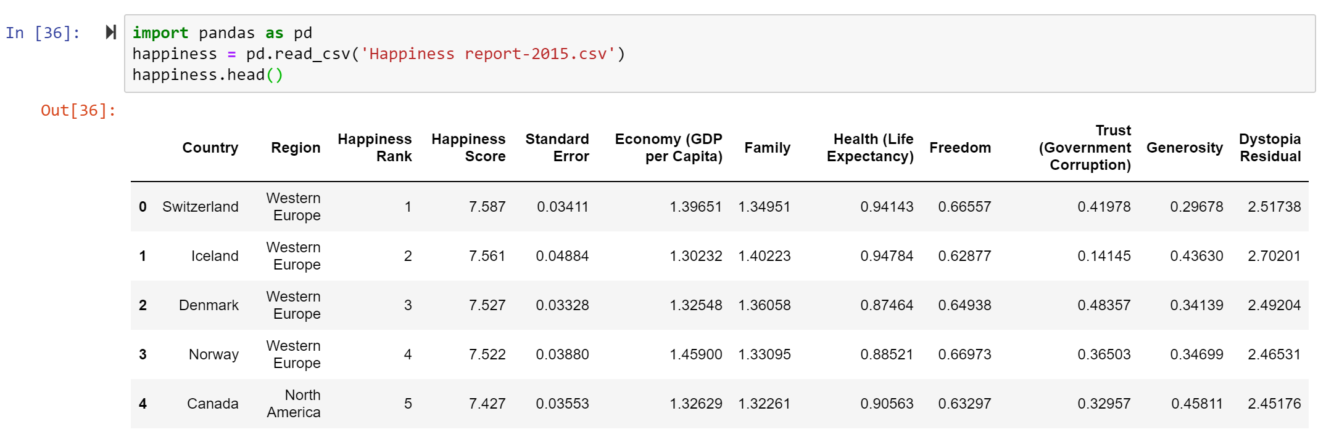

Since in the original dataset the column names include spaces and brackets, it would be sensible to fix the column names to make it easier to call the column name later when creating plots.

***Figure 141: The transformed Dataframe***

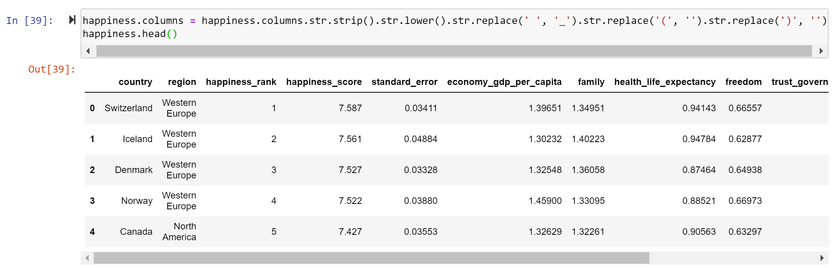

We can use *Matplotlib* to create a scatter plot to examine the relationship between happiness score and economy. This is easy since we already know how to create figure, and all we need do is replace ax.plot() with ax.scatter().

***Figure 142: Creating a scatter plot***

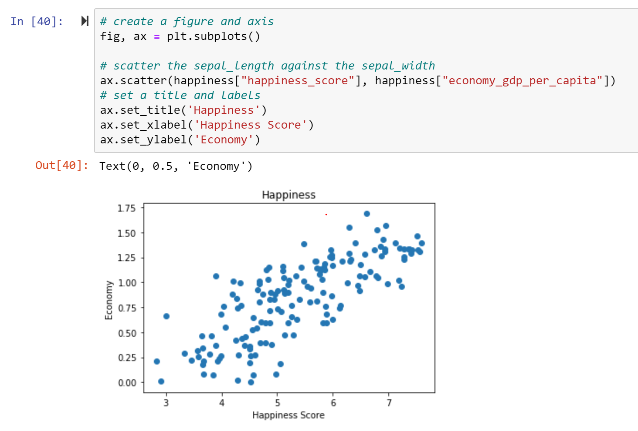

We can also create a Histogram using the hist() method. Histogram is useful for checking the distribution of the data. **Figure 143** shows the frequency distribution of the happiness score for different countries:

***Figure 143: Creating a histogram***

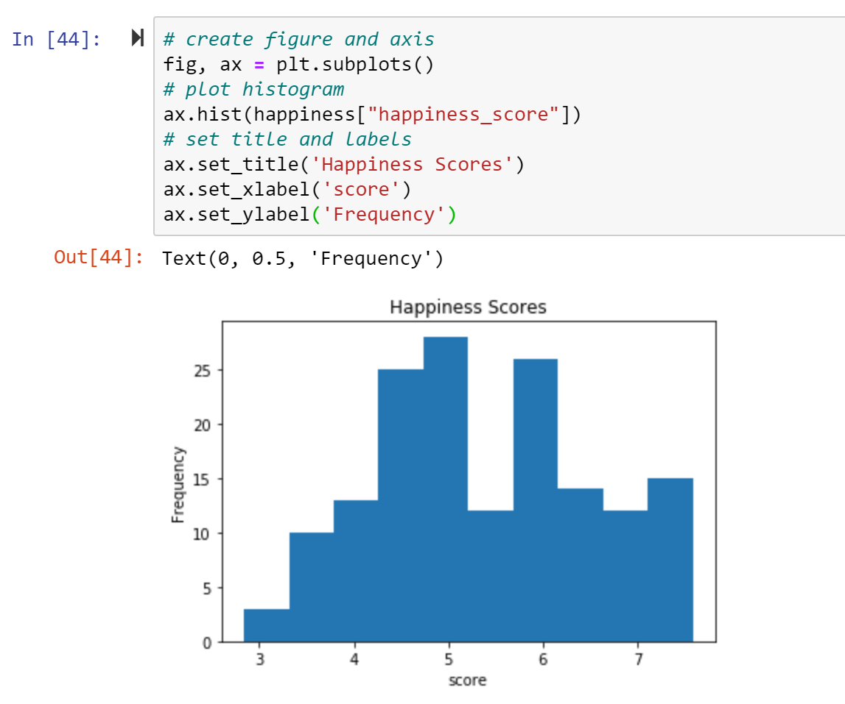

A bar chart can be created using the bar() method. A bar chart is useful for categorical data that doesn’t have a lot of different categories (e.g. less than 30) because else it can get quite messy. Here we use a bar chart to show the happiness score of different regions. Because the bar chart isn’t automatically calculating the average happiness score, we group the data first to get the x (regions) and y (mean happiness score based on region) data (**Figure 144**).

***Figure 144: Creating a bar chart***

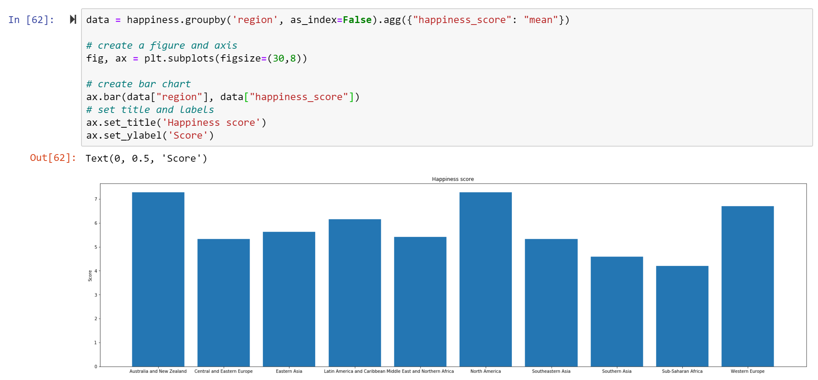

* 1. **Customising Plots in *Matplotlib***

*Matplotlib* allows figure size and DPI (dots per inch) to be specified when the object is created. Figure size is tuple of width and height of the figure in inches, while DPI is effectively the number of pixels per inch. You can use the figsize and dpi keyword argument. For example:

fig = plt.figure (figsize=(4,6), dpi=100)

Or

fig, axes = plt.subplots(figsize=(4,6),dpi=100)

As mentioned in the previous examples, all the axis labels, titles and legends can be added to the figure. To set the figure title, use the set_title method in the axes instance: ax.set_title(“title”). To set the x and y axis labels, use the methods set_xlabel and set_ylabel in the axes instance: ax.set_xlabel(“x”); ax.set_ylabel(“y”). To add legends, it’s a bit different. You need to add the label = “label text” keyword argument first when plots or other objects are added to the figure, and then use the legend method without arguments to add the legend to the figure. Below is the example of setting legends:

Fig,ax = plt.subplots()

ax.plot(x, x**2, label=" quadratic")

ax.plot(x, x**3, label="cubic")

ax.legend()

***Figure 145: Setting the legend for a chart***

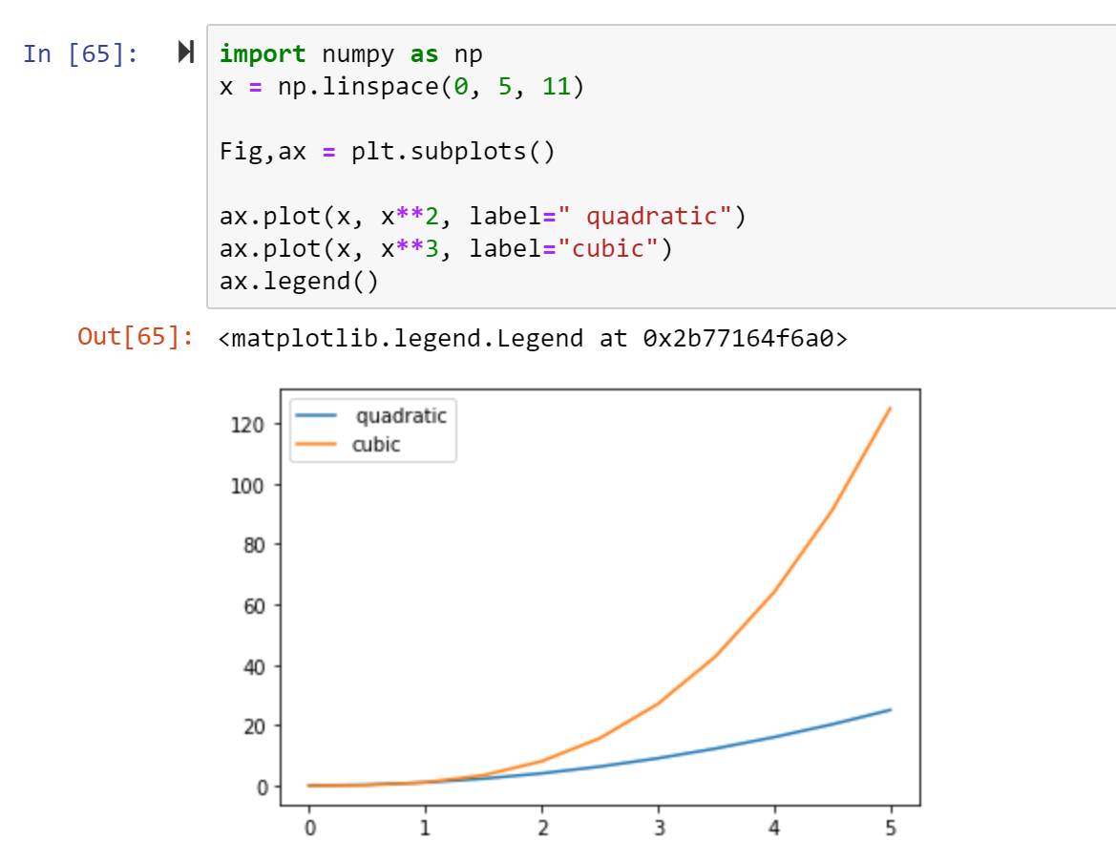

Note that you can also adjust where in the figure the legend is to be drawn. In the above example, it’s default setting but sometimes it might overlap with the plot. Here we can use loc keyword argument to make change. The commonly used is loc =0, which means the Matplotlib will decide the optimal location. But there are also more options to choose. See the documentation page for details. Here are some common examples for you:

ax.legend(loc=0) # let matplotlib decide the optimal location

ax.legend(loc=1) # upper right corner

ax.legend(loc=2) # upper left corner

ax.legend(loc=3) # lower left corner

ax.legend(loc=4) # lower right corner

There are different ways to set up colour for your plot. You can use MATLAB like syntax by adding colour symbols when plotting. For example, we use “*b*” to mean blue while “*r*” for red and “*g*” for green. After the colour symbol you can set the line style as well. For example, “*b.-*” means blue line with dots while “*b --*" means blue dashed line.

***Figure 146: Setting the line colour and style (method #1)***

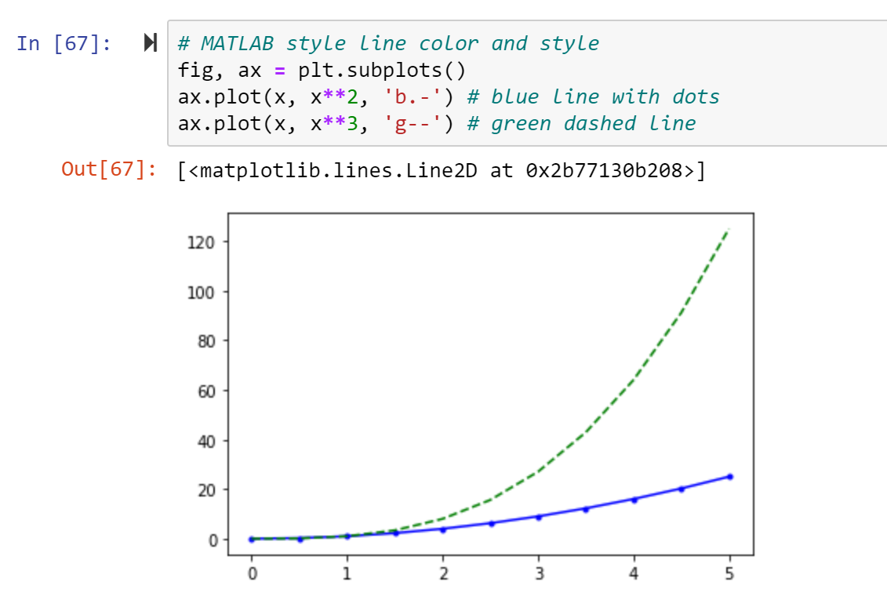

You can also define colours by their name or RGB hex codes and optionally provide an alpha value (alpha indicates opacity) using colour and alpha keyword arguments.

In addition to colour setting, you can also use linewidth or lw keyword argument to change the line width and use the linestyle or ls keyword argument to change the line style. Furthermore, you can use marker keyword argument to change the shape of the line.

***Figure 147: Setting the line colour and style (method #2)***

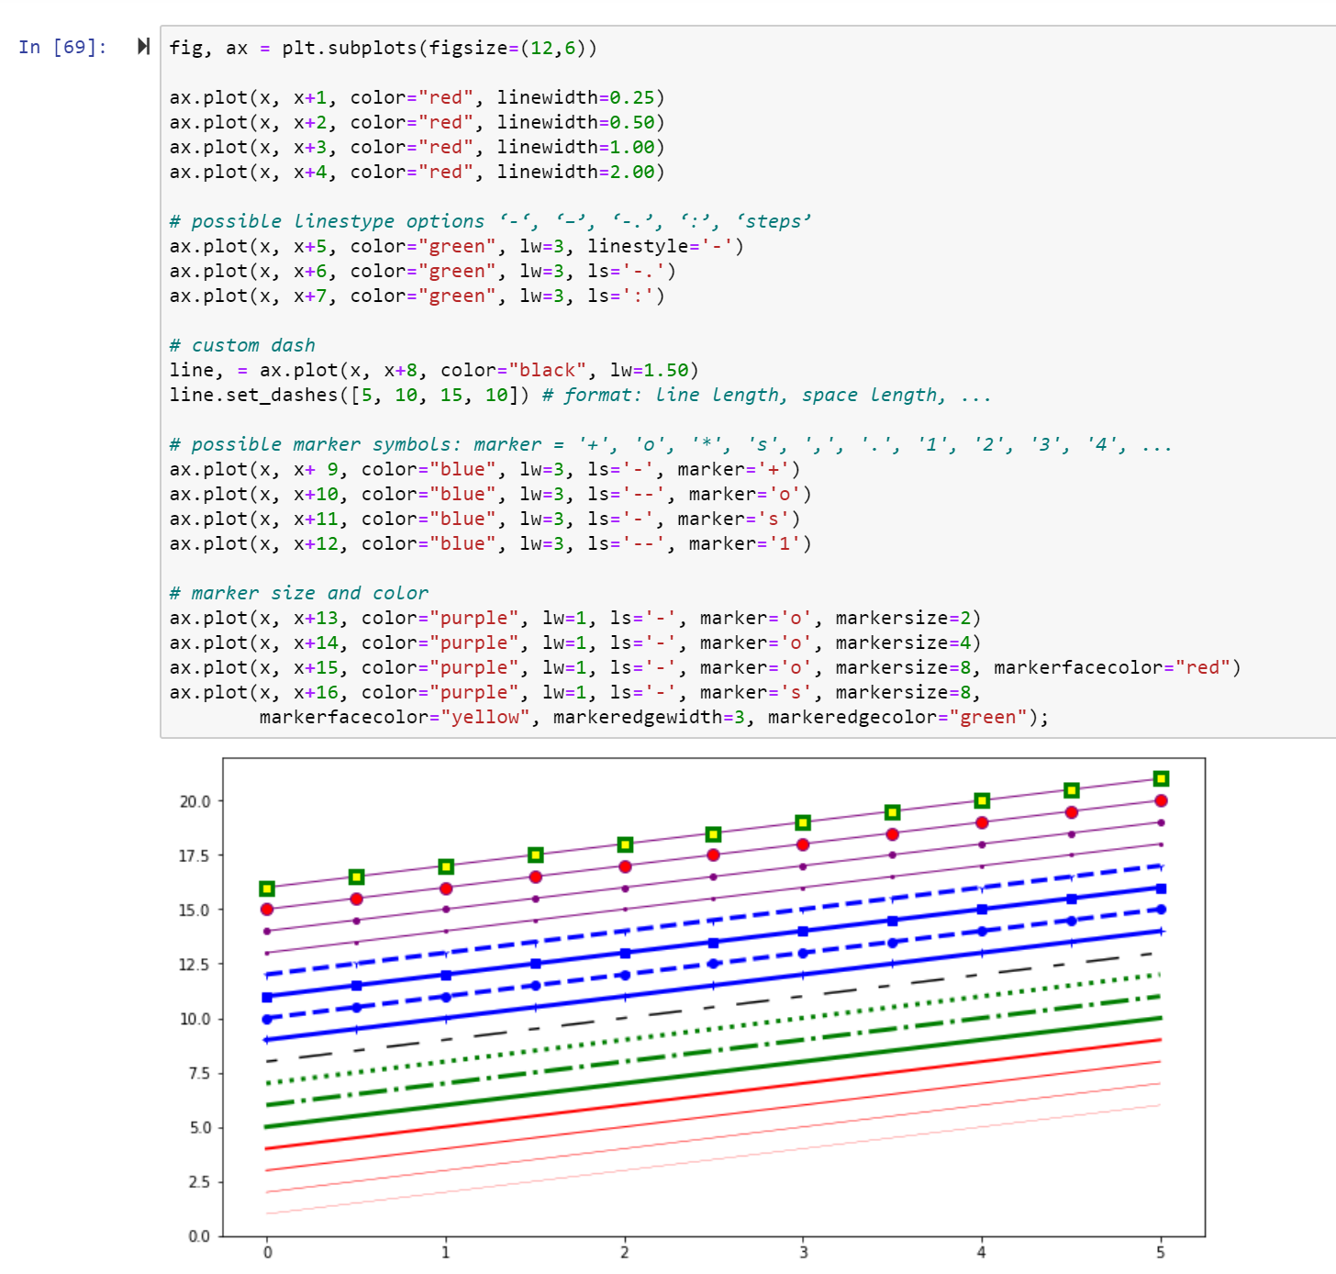

You can configure the range of the axis by using the set_xlim and set_ylim methods in the axes object or using axis(‘tight’) to automatically generate tightly fitted axes ranges:

***Figure 148: Setting the range of axes***

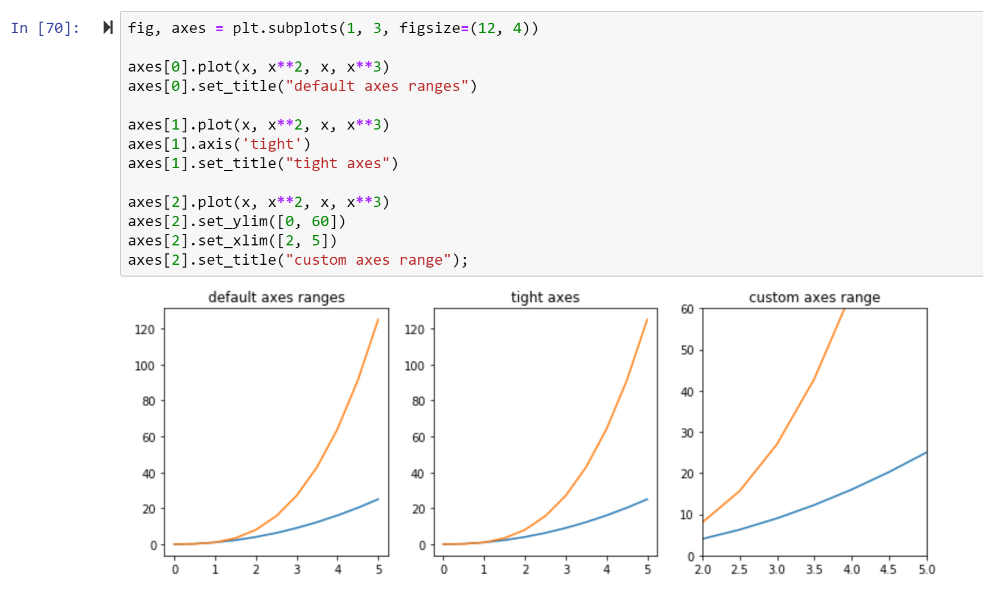

To save a figure to a file we can use the savefig method in the Figure class. *Matplotlib* can generate high-quality output in a number formats, including PNG, JPG, EPS, SVG, PGF and PDF. You can also optionally specify the DPI and choose between different output formats.

fig.savefig("filename.png")

fig.savefig("filename.png", dpi=200)

* 1. **Recommended resources for further reading on *Matplotlib***

<http://www.matplotlib.org> - The project web page for matplotlib.

<https://github.com/matplotlib/matplotlib> - The source code for matplotlib.

<http://matplotlib.org/gallery.html> - A large gallery showcasing various types of plots matplotlib can create. Highly recommended!

* 1. **Visualisation with *Pandas***

*Pandas*, as we explored in chapter five, is a widely-used library that provides data structures such as Dataframes. It also provides data analysis tools like the visualisation that we are going to cover in this section. *Pandas* built-in visualisation is built on *Matplotlib* and it’s very easy to use. It utilises a higher level API than *Matplotlib* which allows us to use shorter code to get the same results. Before you start doing visualisation with *Pandas*, make sure you have installed and imported the package. If you have followed the previous chapter, or are using the Anaconda distribution of Python, this should already be the case.

When we were creating sample plots in *Matplotlib*, we imported the happiness report dataset into a Dataframe. As we are already using *Pandas* to create the Dataframe, it is probably more efficient to keep using this package rather than switch out to *Matplotlib*. Again, we can create line charts, bar charts, scatter plots and histograms directly with Pandas without creating figure and axes. In this section, some examples will be given using the same dataset we used in section 6.2 (the Happiness Report-2015).

To create a scatter plot, we can use df.plot.scatter() to quickly create scatter plot based on the Dataframe. All we need to do is to specify the columns we wish to use as x and y, and optionally you can pass the title name.

***Figure 149: Creating a scatter plot using Pandas***

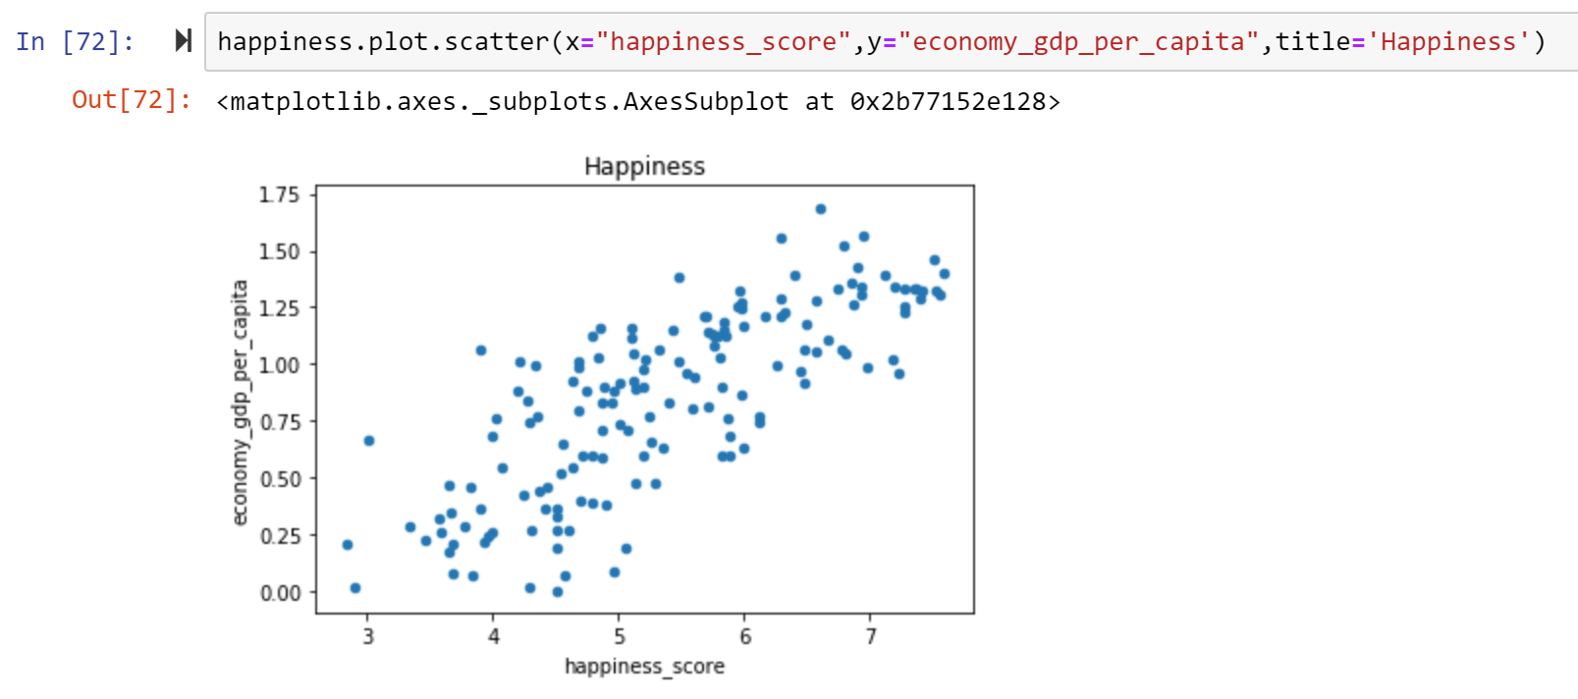

In addition, you can use c to set the colour of the scatter plots based on another column and use cmap to indicate colour map to use. For all the colour maps, check out: <http://matplotlib.org/users/colormaps.html>.

***Figure 150: Setting a colourmap for a scatter plot in Pandas***

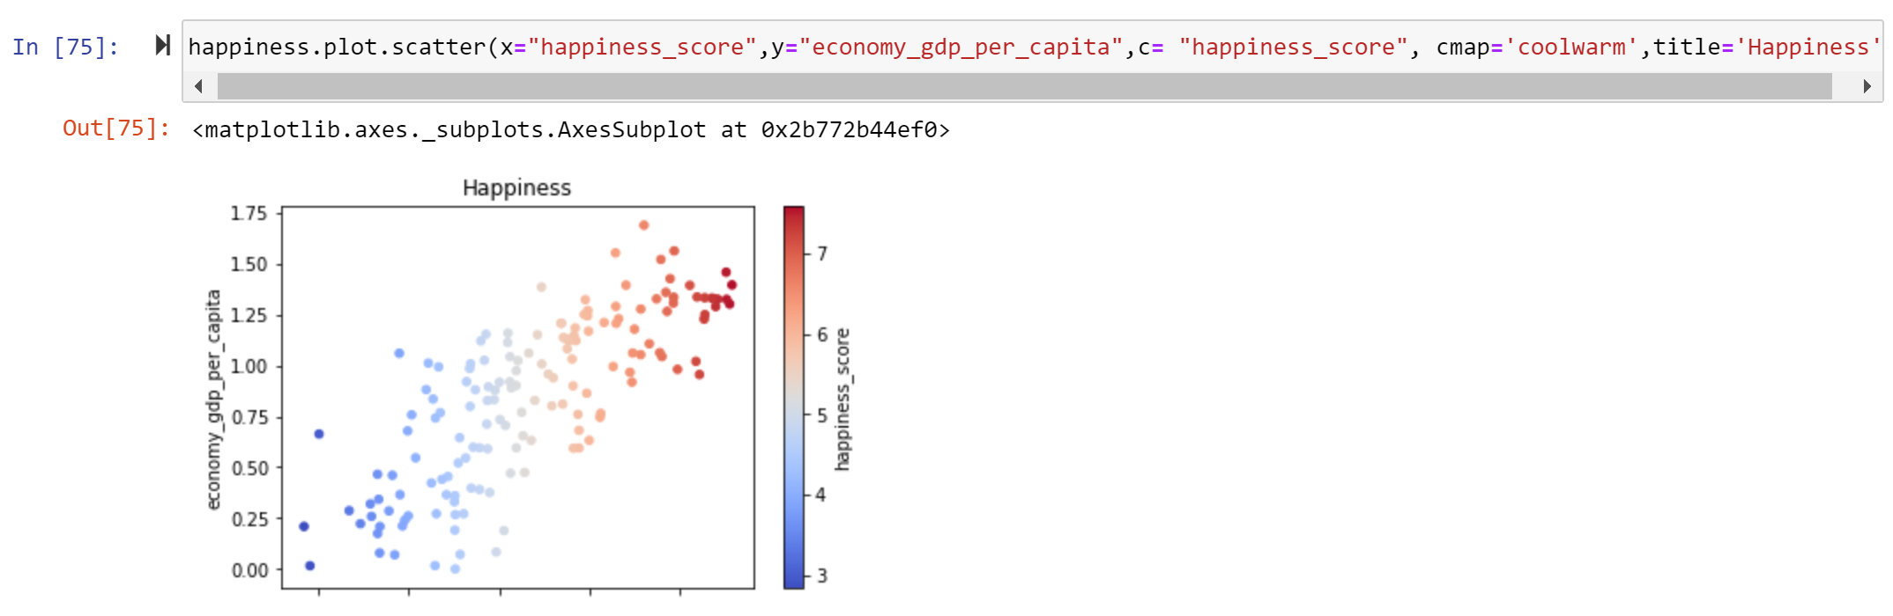

Histograms can also be easily created using df[column_name].plot.hist():

***Figure 151: Creating a histogram in Pandas***

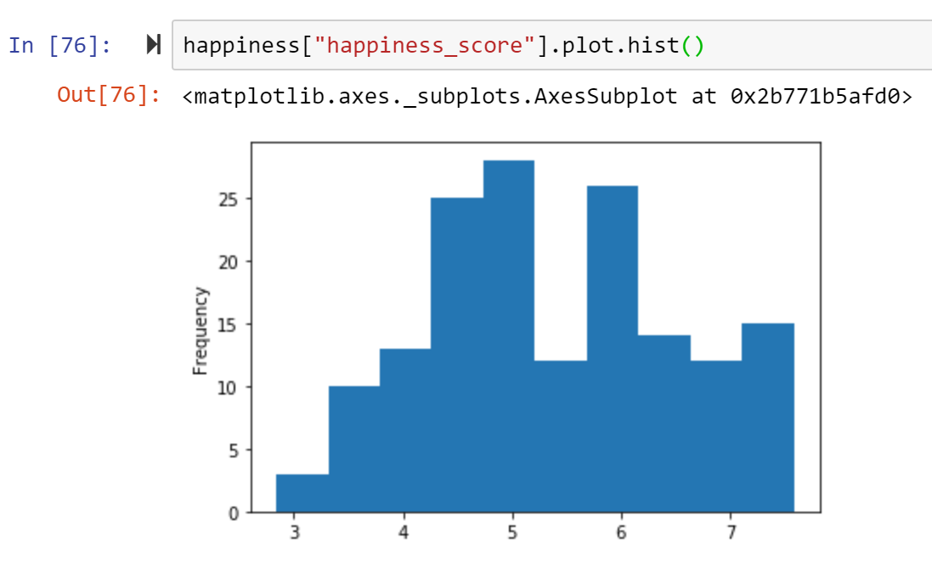

You can also easily create multiple histograms using the dataset. The subplots argument specifies that we want a separate plot for each feature and the layout specifies the number of plots per row and column.

***Figure 152: Creating multiple histograms in Pandas***

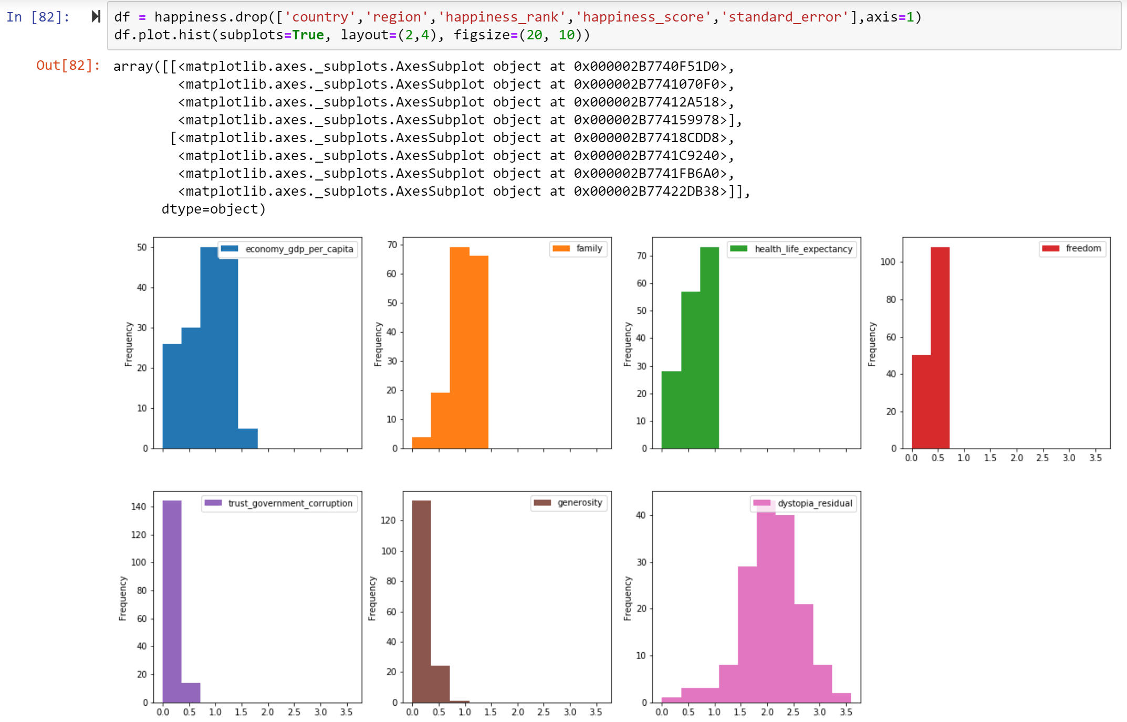

To create bar plot, we can use df.plot.bar() method. First, we group the data by the regions, sort the values from smallest to the biggest and then show them in a bar chart.

***Figure 153: Creating a bar chart in Pandas***

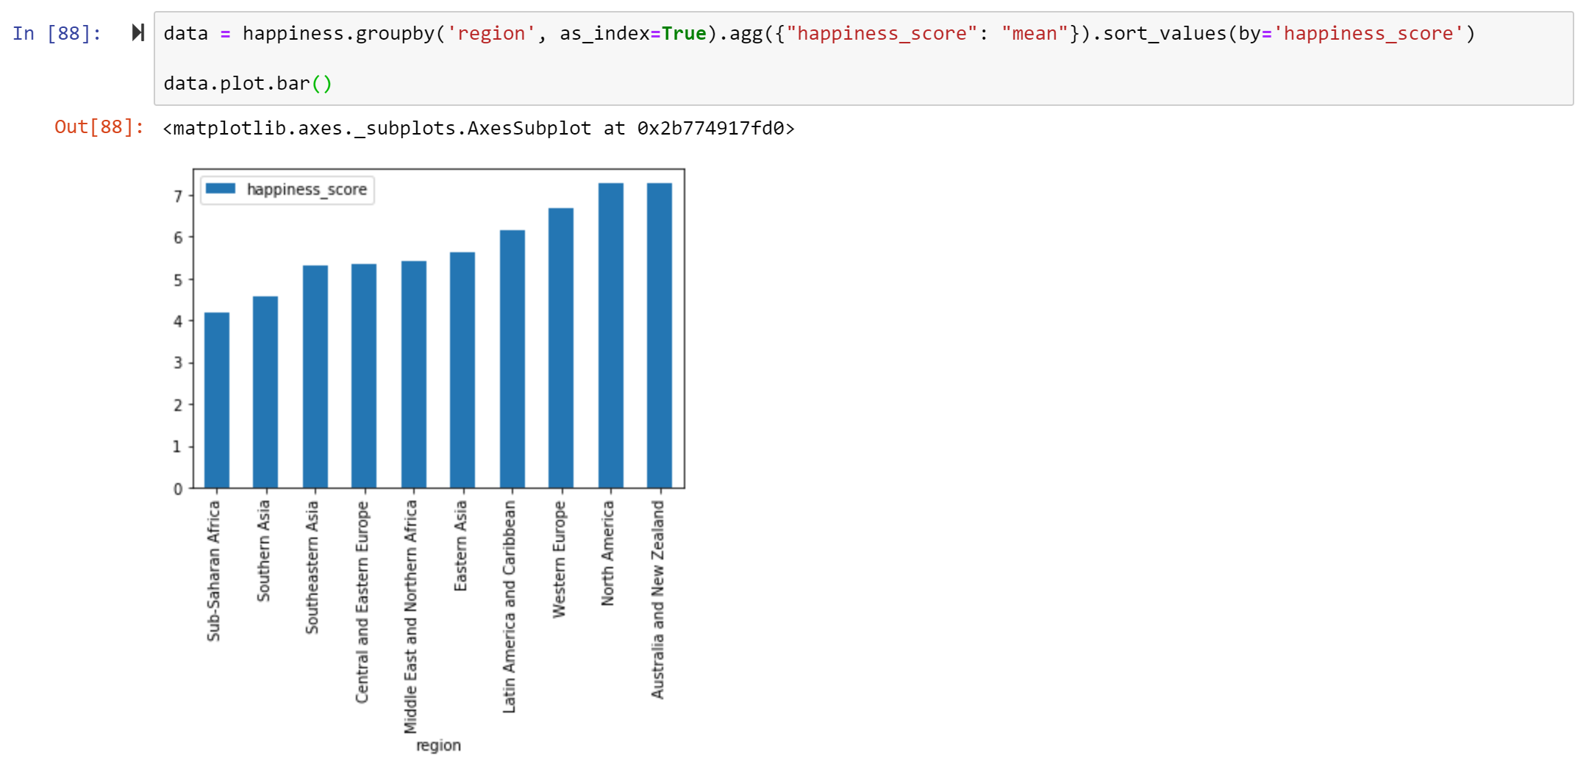

You can change the vertical bar chart to a horizontal bar chart using df.plot.barh() method.

***Figure 154: Creating a horizontal bar chart in Pandas***

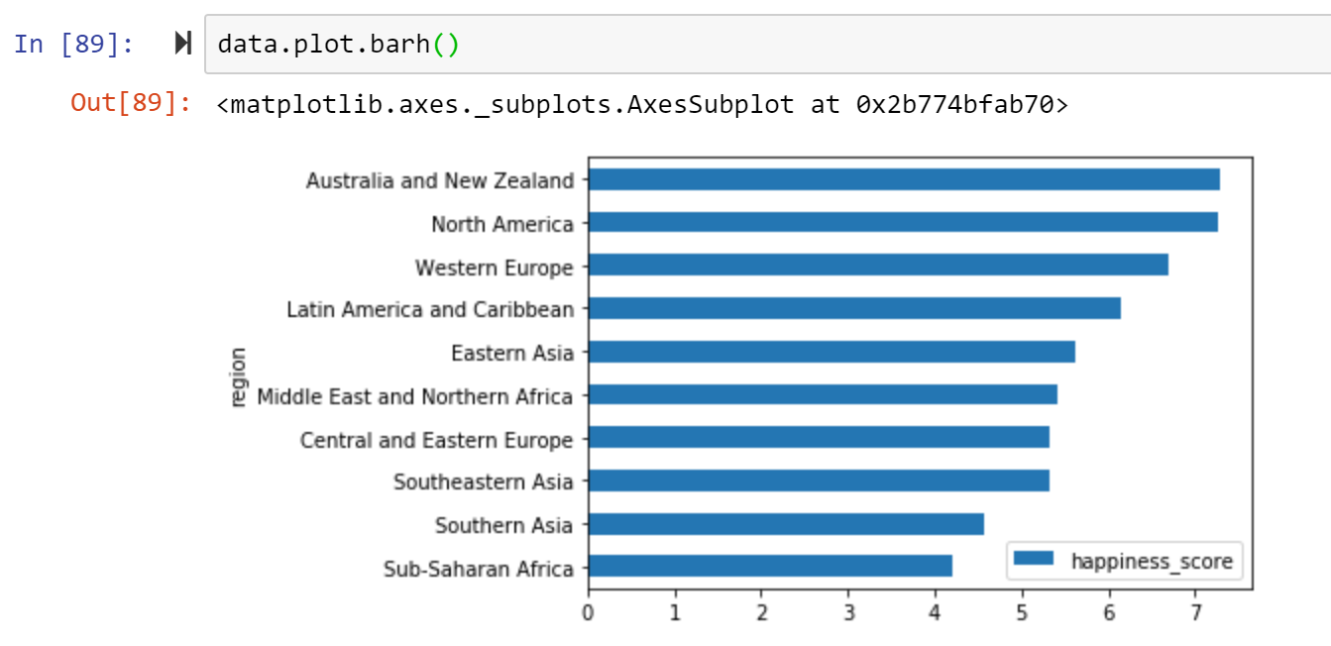

You can also set the colour for your bar chart using color = [colour name].

Line charts in *Pandas* can be easily created using the df.plot.line() method. In *Pandas*, if you don’t specify which column you want to create the line chart, it automatically plots all available numeric columns of the whole dataset.

***Figure 155: Creating a line chart in Pandas***

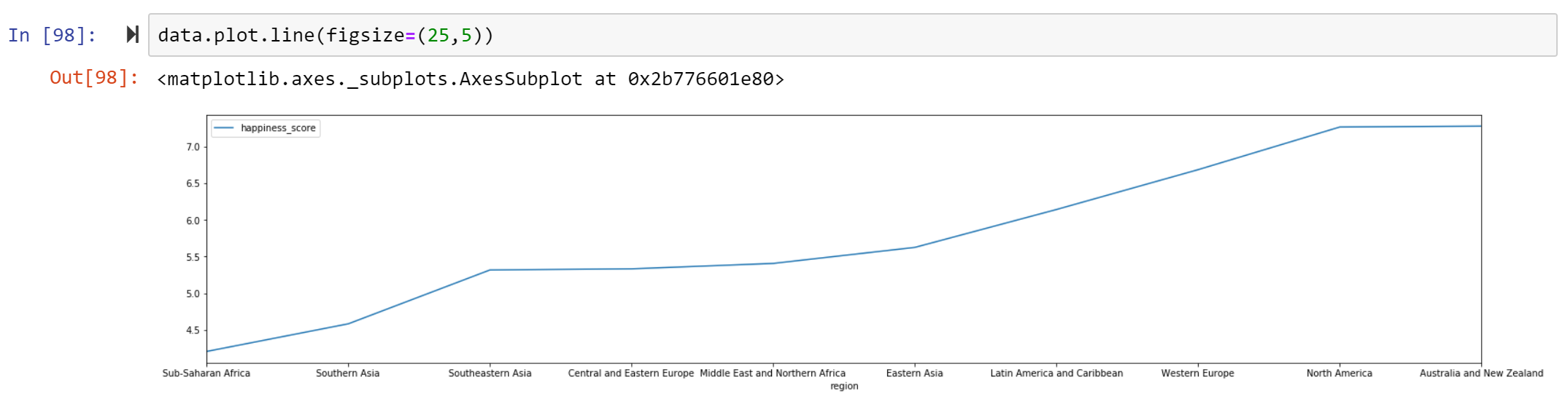

*Note: this is not the best example as the dataset is more suited to bar charts (and similar) than line charts. A line chart would be more suited to use-cases such as time-series data.*

There are also more other chart types that are available in Pandas built-in visualisation. Here are the types that might be commonly used in the practice:

1. df.plot.area
2. df.plot.barh
3. df.plot.density
4. df.plot.hist
5. df.plot.line
6. df.plot.scatter
7. df.plot.bar
8. df.plot.box
9. df.plot.hexbin
10. df.plot.kde
11. df.plot.pie

You can also just call df.plot(kind='hist') or replace that kind argument with any of the key terms shown in the list above (e.g. 'box', 'barh', etc.)

Similar to what can do in *Matplotlib*, you can have settings for your plot with *Pandas* visualisation, such as setting titles, legends, axis labels etc. There are different ways to realise these. You can set the arguments directly when you are creating the plot. Here is an example:

data.plot(kind='barh',color='red',xlim=(0,8),title='Happiness_report',figsize=(5,5), legend=False)

For more details of the arguments, you can explore pandas.DataFrame.plot (<https://pandas.pydata.org/pandas-docs/stable/reference/api/pandas.DataFrame.plot.html>).

Additionally, you can also stick with the approaches used for *Matplotlib* for setting or formatting your plots. For example:

data.plot(kind='barh',legend=False, figsize=(5,5),color=’red’)

plt.title(Happiness Report',color = 'black')

plt.xticks(color = 'black')

plt.yticks(color = 'black')

plt.xlabel('Happiness_score',color = 'black')

plt.ylabel(Region',color = 'black')

plt.savefig('bar_happiness.png')

Furthermore, you can use style sheets from Matplotlib to make your plots look nicer. These style sheets include plot_bmh, plot_fivethirtyeight, plot_ggplot and more (<https://matplotlib.org/gallery.html#style_sheets>). They basically create a set of style rules that your plots follow. By set up the style you can keep all your visualisation consistent. Here are some examples of the styles:

plt.style.use('ggplot')

plt.style.use('bmh')

plt.style.use('dark_background')

plt.style.use('fivethirtyeight')

***Figure 156: Style examples for Pandas plots***

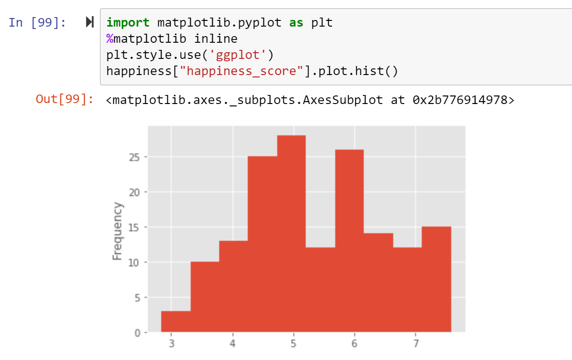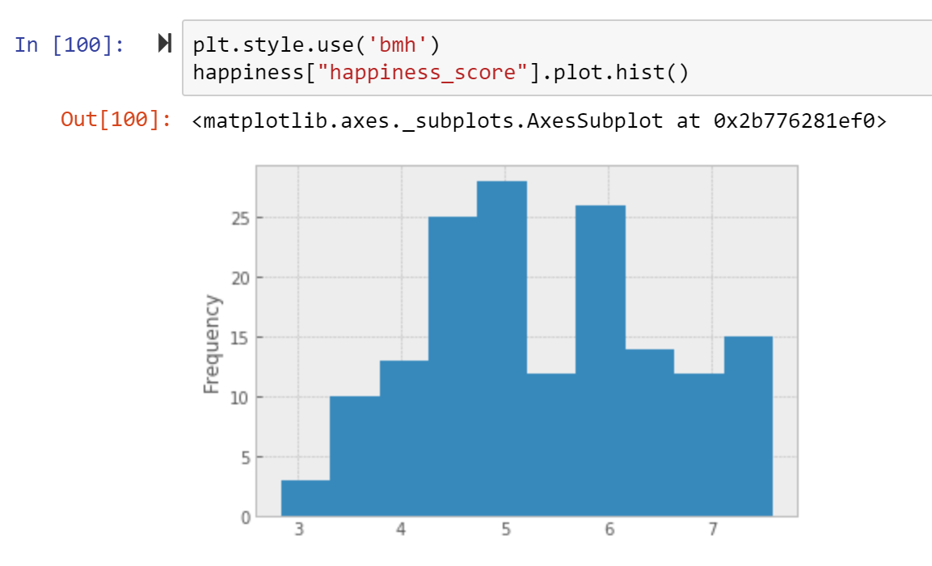

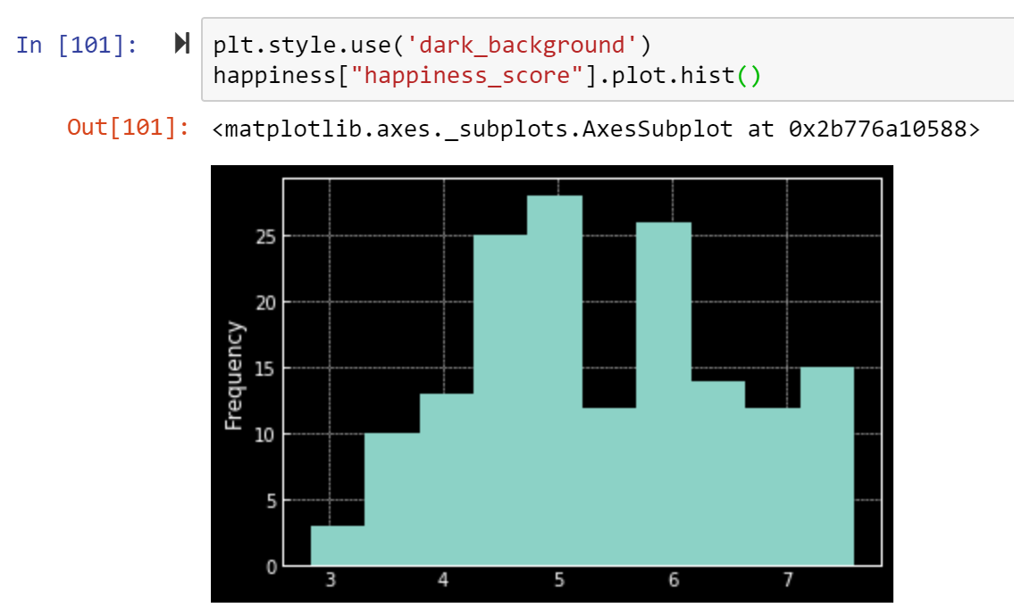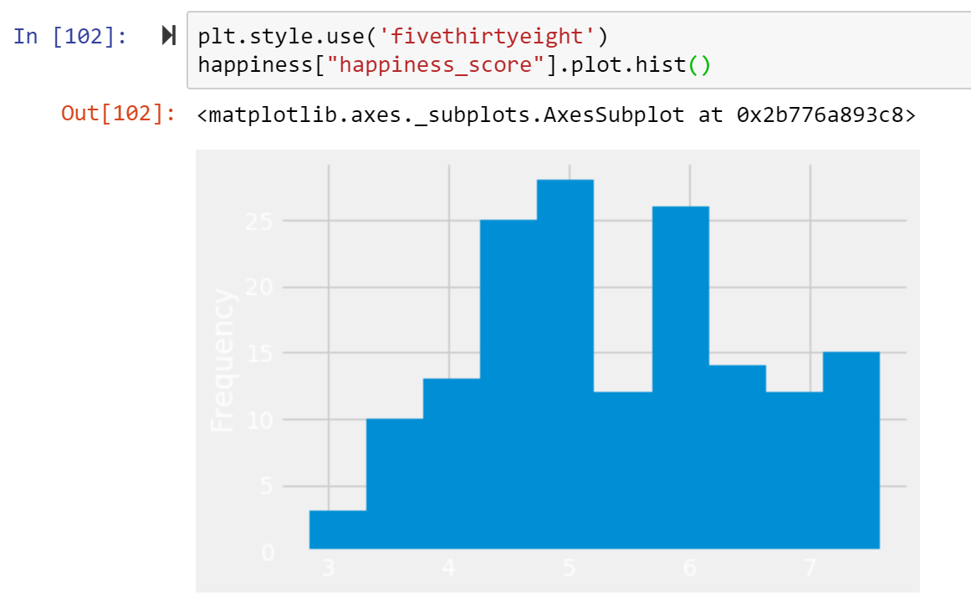

* 1. **Visualisation with *Seaborn***

*Seaborn* is a Python data visualization library also based on *Matplotlib*. It provides a high-level interface for drawing attractive and informative statistical graphics. It can be more effective than *Matplotlib* by using only one line to create one graph while using *Matplotlib* you need to write multiple lines. It builds on top of matplotlib and integrates closely with *Pandas* data structures.

Before you start using *Seaborn*, you need to import the library first (note: *Seaborn* is also included automatically in the Anaconda distribution but will need to be manually installed on other versions of Python).

import seaborn as sns

%matplotlib inline

*Seaborn* provide some built-in dataset and we can use some sample dataset to practice using sns.load_dataset() method. Please check <https://seaborn.pydata.org/generated/seaborn.load_dataset.html> to see how you can load the dataset and check <https://github.com/mwaskom/seaborn-data> to see what datasets are available for you to use. In this tutorial, we will use some sample datasets from *Seaborn*. (If you don’t want to work with sample data, you can use pd.read_csv() to import any datasets that you want to work with.)

*Seaborn* has a set of plotting functions. Before we go deeper to specific features offered by each function, we will have an overview of the seaborn plotting functions. Most of the documentations in seaborn are structured around three modules, namely distribution module, relational module, and categorical module.

In addition, it’s noted that seaborn functions can be classified as “figure-level” or “axes-level”. Each module has a single figure-level function, which offers a unitary interface to its various axes-level functions. The organisation of this is summarised in:

***Figure 157: Classification of Seaborn functions***

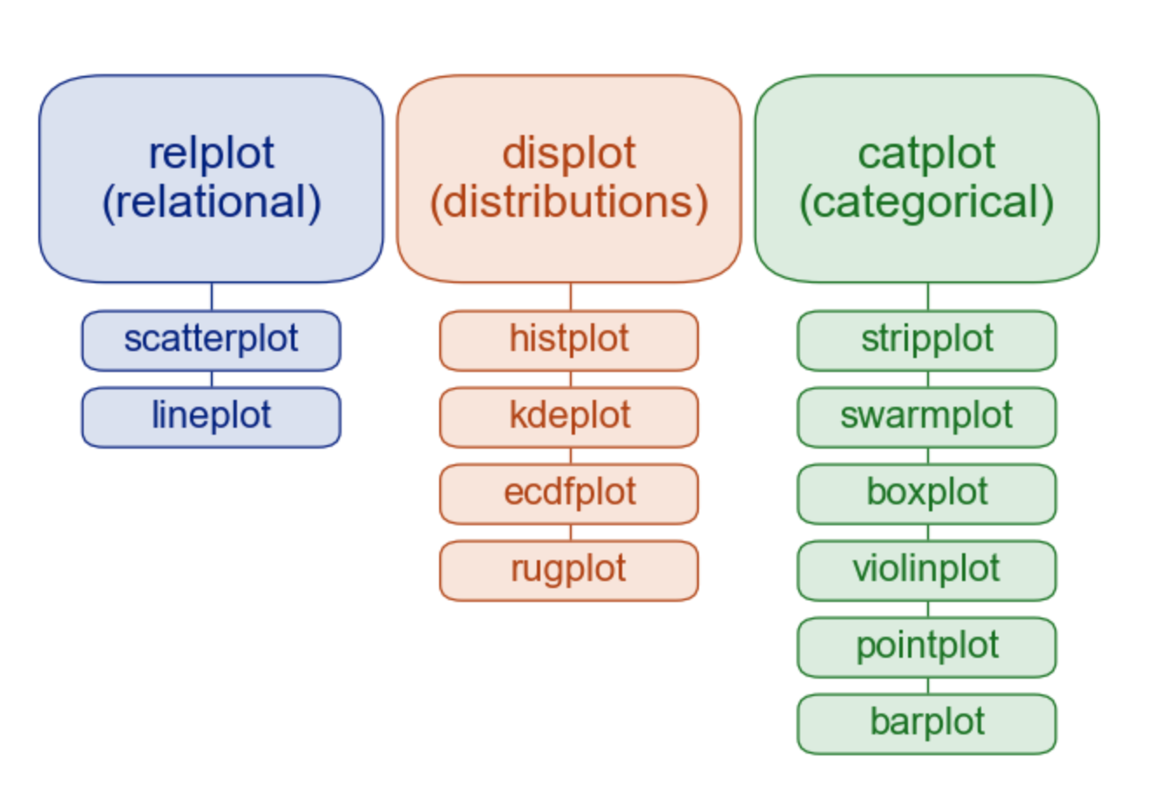

Here sns.relplot(), sns.displot() and sns.catplot() are the figure-level function for the relational, distribution and categorical module respectively. For example, displot() draws histogram in default mode using the following code:

penguins = sns.load_dataset("penguins")

sns.displot(data=penguins, x="flipper_length_mm", hue="species", multiple="stack")

If you want to draw a kernel density plot, instead of using sns.kdeplot(), you use kind keyword argument within displot(), like this:

sns.displot(data=penguins, x="flipper_length_mm", hue="species", multiple="stack", kind="kde")

The above examples show figure-level function in *Seaborn*. If instead you use something like sns.kdeplot(data=penguins, x="flipper_length_mm", hue="species", multiple="stack"), you are creating an axes-level function.

The most useful feature offered by the figure-level functions is that they can easily create figures with multiple subplots. For example, instead of stacking the three distributions for each species of penguins in the same axes, we can “facet” them by plotting each distribution across the columns of the figure:

sns.displot(data=penguins, x="flipper_length_mm", hue="species", col="species")

Generally, the figure-level functions wrap their axes-level counterparts and pass the kind-specific keyword arguments (such as the bin size for a histogram) down to the underlying function, which means with figure-level functions there is less flexibility. However, axes-level functions can make self-contained plots. Here we will come back to the part on how we create figure and axes in *Matplotlib*. So, we need to import *Matplotlib* to use together with seaborn. Here is an example:

import matplotlib.pyplot as plt

%matplotlib inline

figure, axs = plt.subplots(1, 2, figsize=(8, 4), gridspec_kw=dict(width_ratios=[4, 3])) # create figure and axes

sns.scatterplot(data=penguins, x="flipper_length_mm", y="bill_length_mm", hue="species", ax=axs[0]) #axe 1

sns.histplot(data=penguins, x="species", hue="species", shrink=.8, alpha=.8, legend=False, ax=axs[1]) #axe 2

figure.tight_layout()

In this way, it’s much easier for you to adjust what you want for each axe in your plot. To sum up, figure-level functions can create a cleaner plot, but if you want to make a complex figure with multiple different plot “kinds” it is recommended to create the figure and axes using *Matplotlib* first and the to fill in individual components using axes-level functions in *Seaborn*.

Next, we will introduce different kinds of visualisation that can be realised using seaborn. It will include distribution, relational and categorical plotting. In addition, we will have a look at how to create multi-plot grids and matrix plotting. Here we will use the built-in dataset from *Seaborn* called “tipis.csv” (the same dataset we used in chapter five).

tips = sns.load_dataset('tips')

tips.head()

***Figure 158: Importing a built-in dataset in Seaborn***

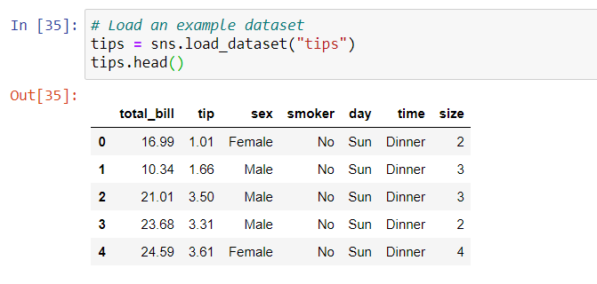

There are different kinds of plots that allow us to visualise the distribution of the dataset. Here we will try axes-level functions including distplot(), histplot(), kdeplot() and also figure-level function displot(). Furthermore, jointplot() will be shown on how to match up two histogram for bivariate data.

We can simply use distplot() to draw the histogram of the data with kernel density plot. To remove the kde layer, you can add the kde=False argument inside the distplot() to only have the histogram.

***Figure 159: Creating histograms using the distplot() method***

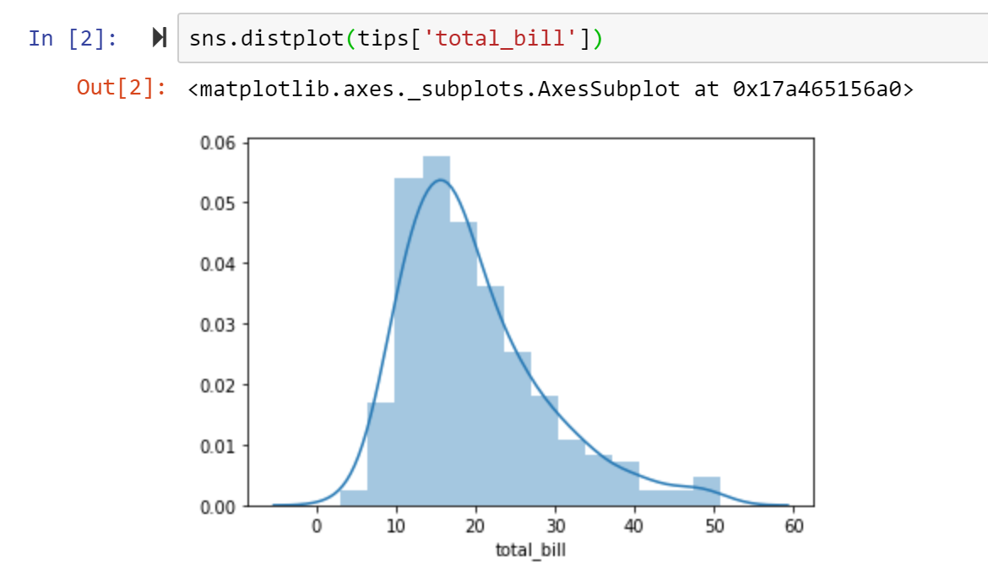

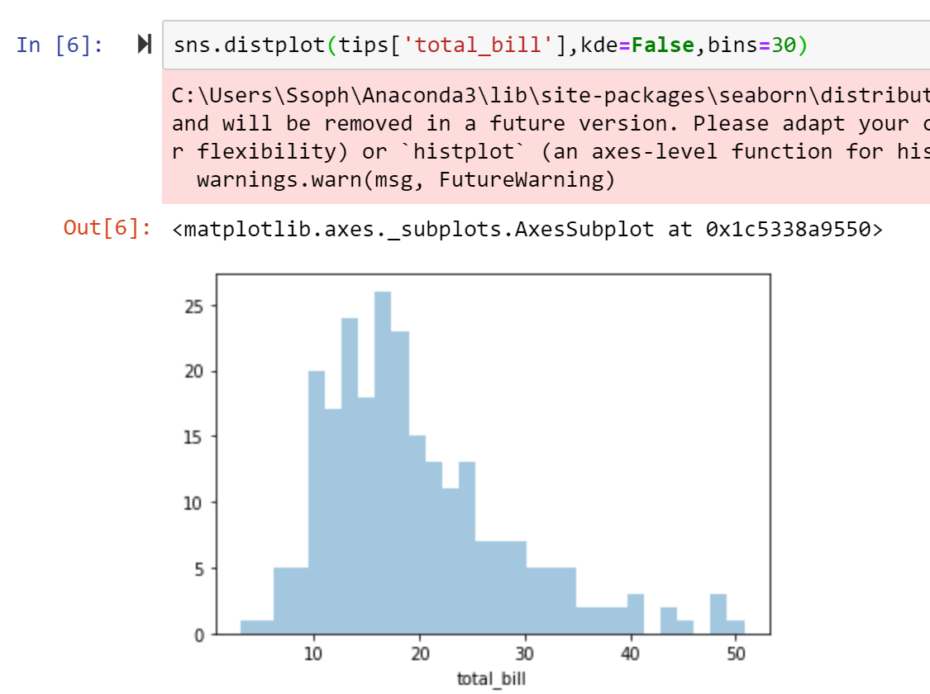

However, in the most recent version of seaborn, distplot() is deprecated, meaning it will be removed in a future version. histplot() is more recommended to use in this case. Next we will show the example with histplot(). Please note that you may get the error when you are running histplot() for the first time (as shown in figure). That is because your version of *Seaborn* is not uptodate. What you need to do is just to upgrade your *Seaborn* version to “0.11.1”, following the instructions in chapter four, and then you can restart the kennel and run the code again as shown in **Figure 160**.

***Figure 160: Creating a histogram using the histplot() method***

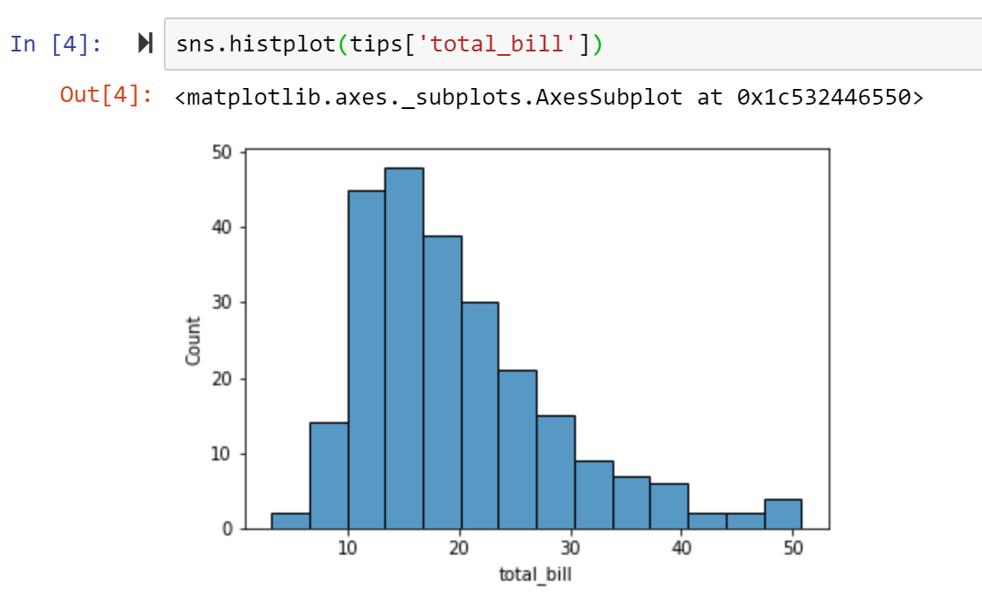

Of course, as we mentioned previously, you can also use the figure-level function displot() to draw the histogram which looks almost the same as histplot().

By default, displot()/hisplot() chooses an automatic bin size based on the variance of the data and the number of observations. However, it is advisable to check your impressions of the distributions are consistent across different bin sizes. You can easily adjust the bin size in *Seaborn* by using then bins or binwidth keyword argument.

***Figure 161: Adjusting bin sizes in Seaborn histograms***

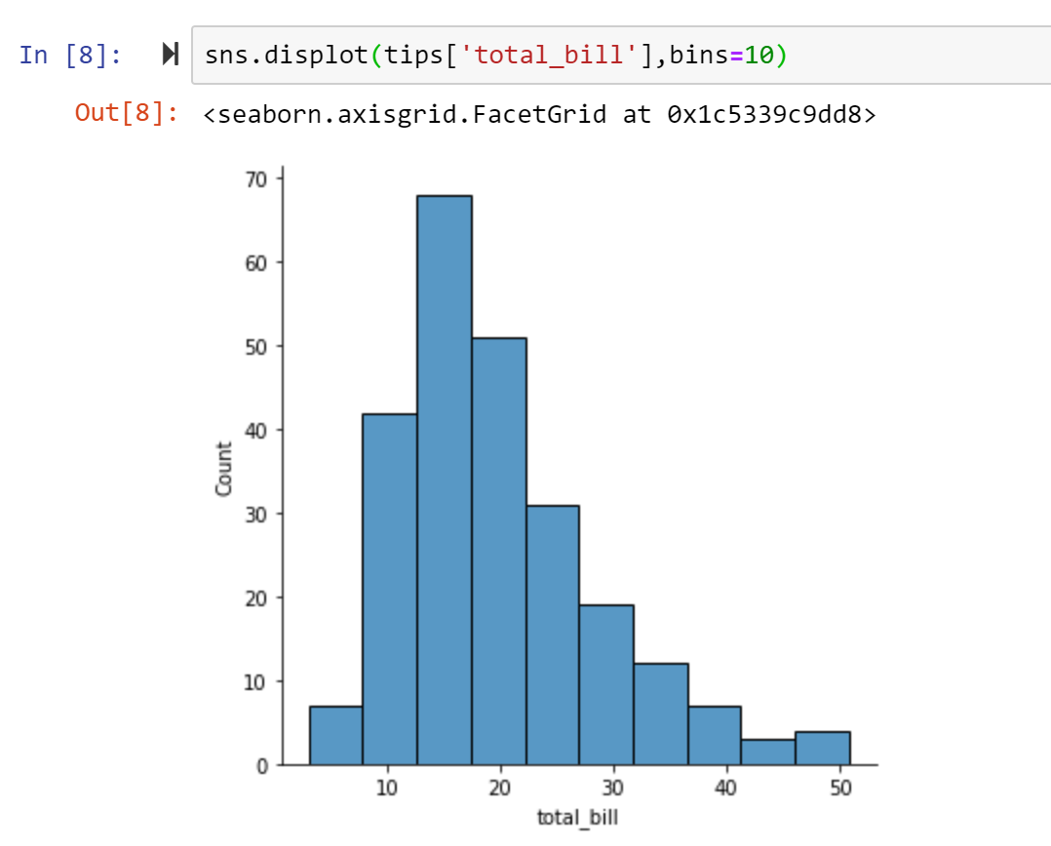

displot() and histplot() provide support for conditional subsetting via the hue semantic. Assigning a variable to hue will draw a separate histogram for each of its unique values and distinguish them by colour.

***Figure 162: Conditional subsetting of a histogram***

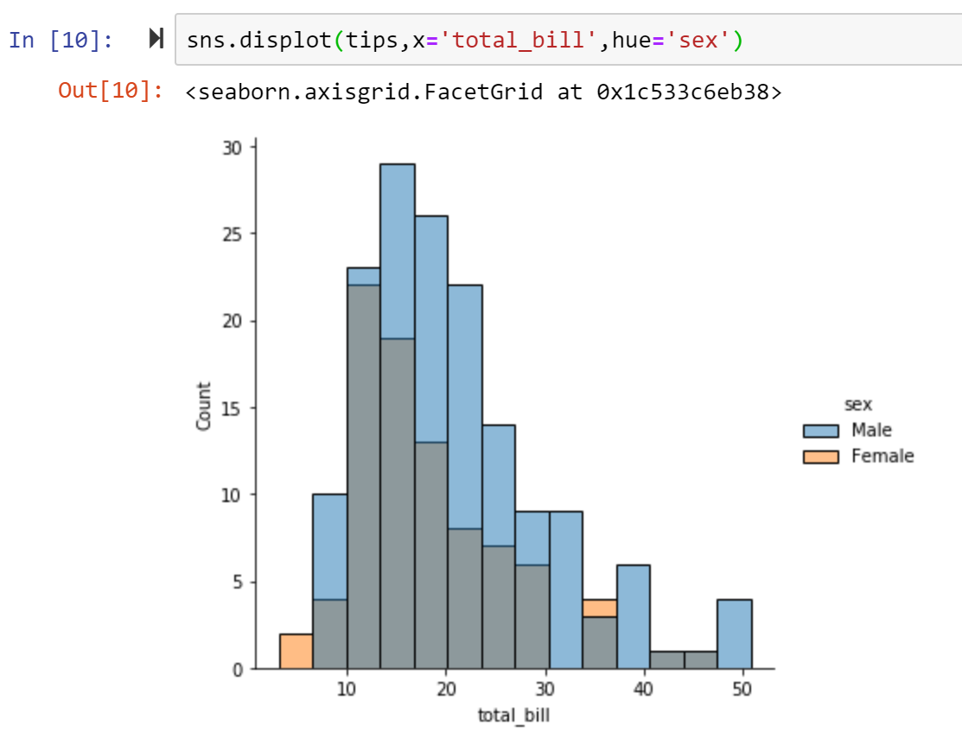

By default, the different histograms are “layered” on top of each other and, in some cases, they may be difficult to distinguish. One option is to change the visual representation of the histogram from a bar plot to a “step” plot:

***Figure 163: Changing the visual representation of a histogram (step plot)***

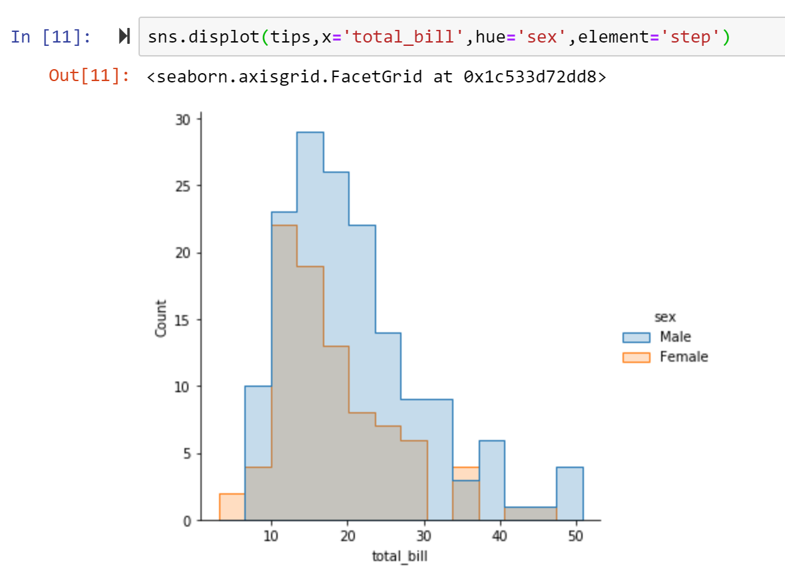

Alternatively, instead of layering each bar, they can be “stacked”, or moved vertically. In this plot, the outline of the full histogram will match the plot with only a single variable:

***Figure 164: Changing the visual representation of a histogram (stacked plot)***

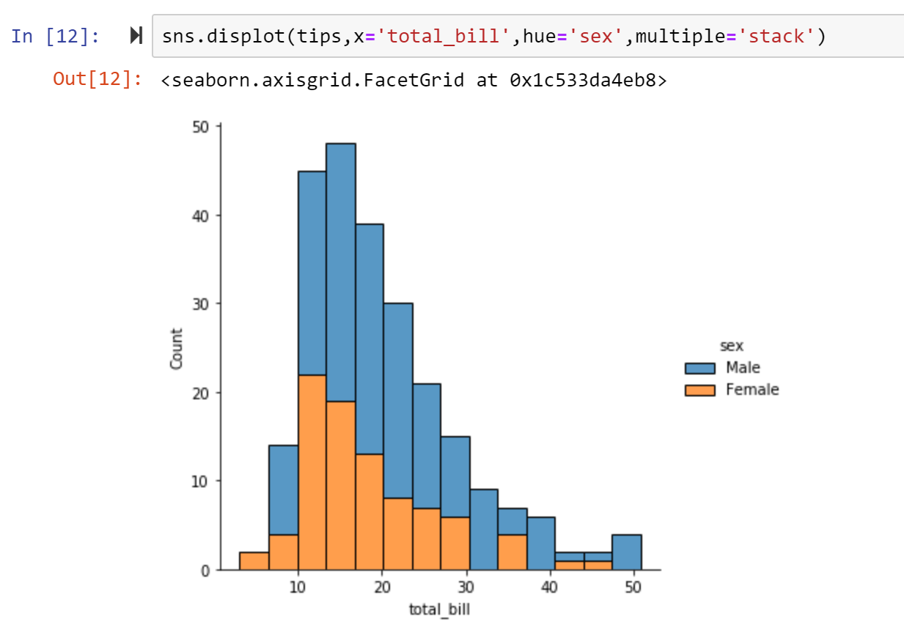

Another option is to “dodge” the bars, which moves them horizontally and reduces their width. This ensures that there are no overlaps and that the bars remain comparable in terms of height. However, this only works well when the categorical variable has a small number of levels:

***Figure 165: Changing the visual representation of a histogram (clustered plot)***

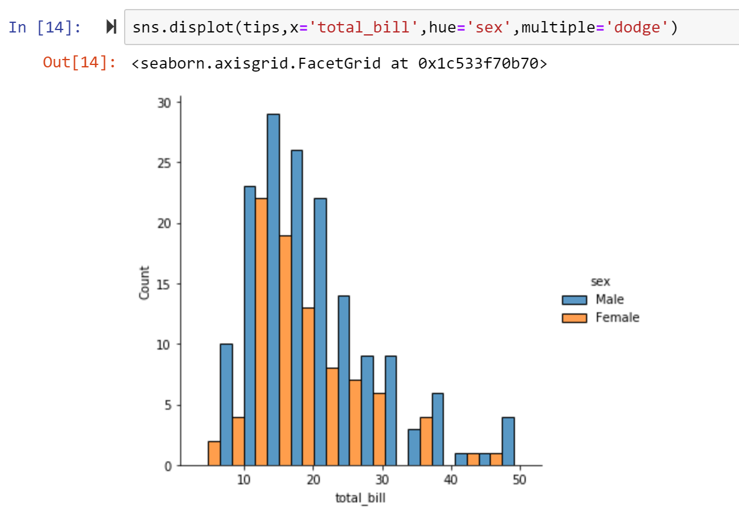

Since displot() is a figure-level plot, it’s possible to draw individual distribution in separate subplot based on the second variable (in this case it’s the “sex”) instead of using hue.

***Figure 166: Creating a multi-histogram in Seaborn***

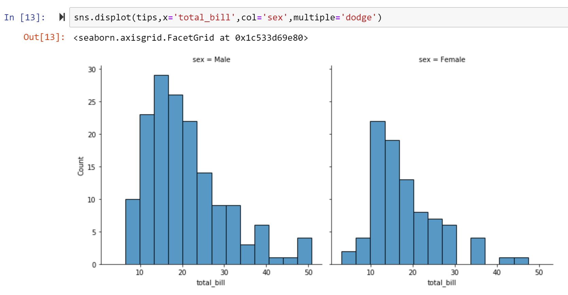

A Kernel Density Plot (KDE) replaces every single observation with a Gaussian (Normal) distribution centred around that value. For example:

***Figure 167: Creating a KDE plot in Seaborn (method #1)***

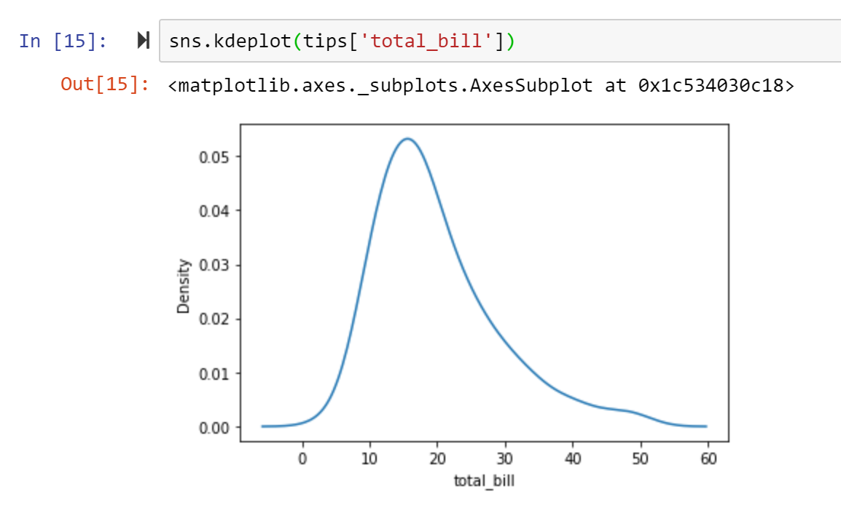

Or you can use displot() adding the kind parameter to draw the KDE plot:

***Figure 168: Creating a KDE plot in Seaborn (method #2)***

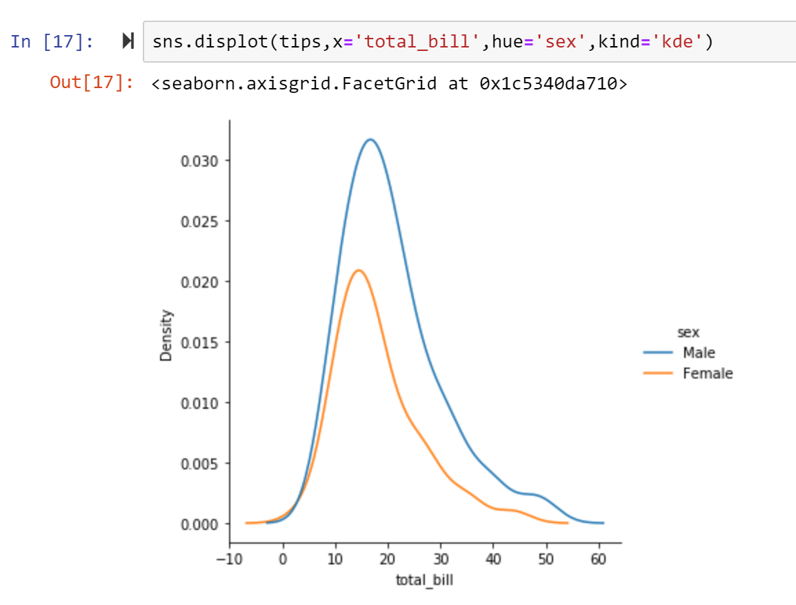

As with histograms, if you assign a hue variable, a separate density estimate will be computed for each level of that variable. You can also fill the area for each KDE:

***Figure 169: Assigning hue to a KDE plot***

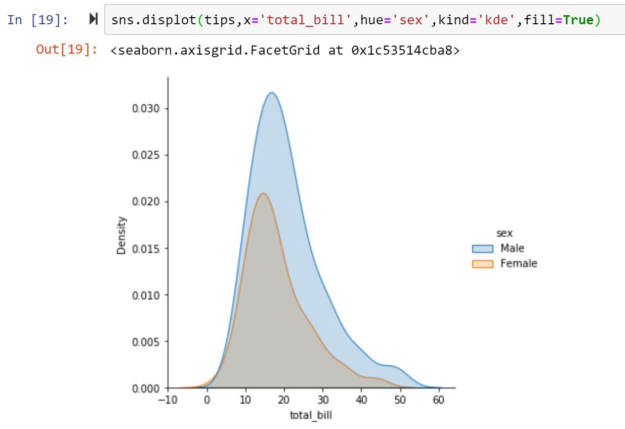

In addition, as with the histogram, you can stack the kernel (using multiple = ‘stack’) so that you can see the full picture of the distribution as a whole.

All above are the examples of univariate distributions (single variable). Next, we will see some examples on how to visualise bivariate distributions. It’s pretty straight-forward that we can simply assign y in displot() to draw the bivariate distribution. For example:

***Figure 170: Visualising bivariate distributions in Seaborn***

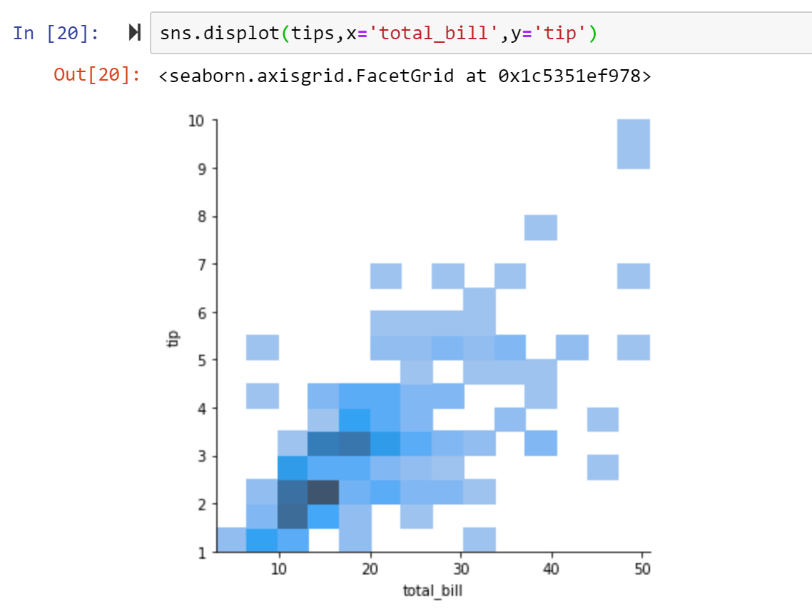

A bivariate histogram bins the data within rectangles that tile the plot and then shows the count of observations within each rectangle with the fill colour (analogous to a heatmap). Similarly, a bivariate KDE plot smoothes the (x, y) observations with a 2D Gaussian:

***Figure 171: Visualising a bivariate distribution with KDE in Seaborn***

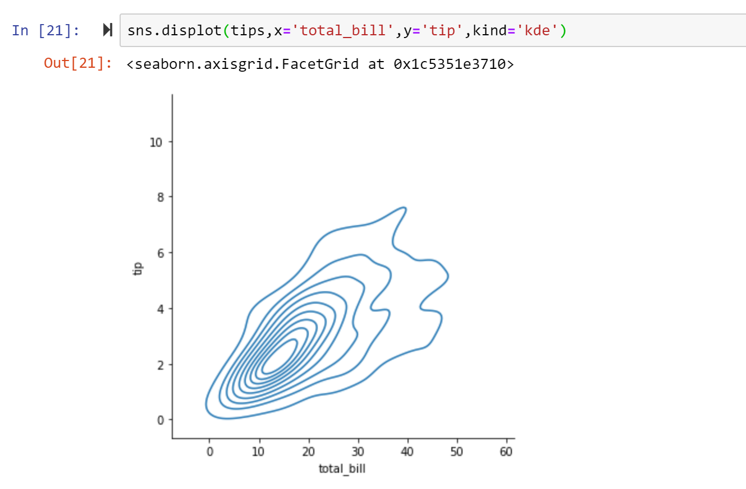

To better interpret the graph, you can add a colour bar to show the mapping between counts and a colour intensity:

***Figure 172: Adding colour representation to a bivariate distribution visualisation***

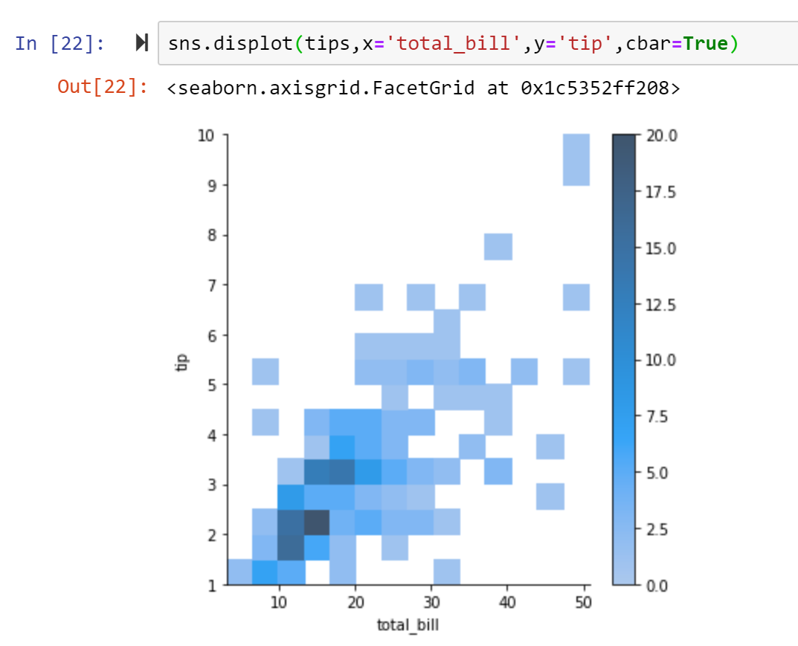

As with a univariate distribution plotting, you can assign a hue variable to plot multiple heatmap using different colours.

In the bivariate distribution, we will visualise the distribution combining two variables. But if we still want to see the single distribution of each variable, we can use jointplot() to get both the bivariate distribution and univariate distribution.

***Figure 173: Creating joint distribution using the jointplot() method***

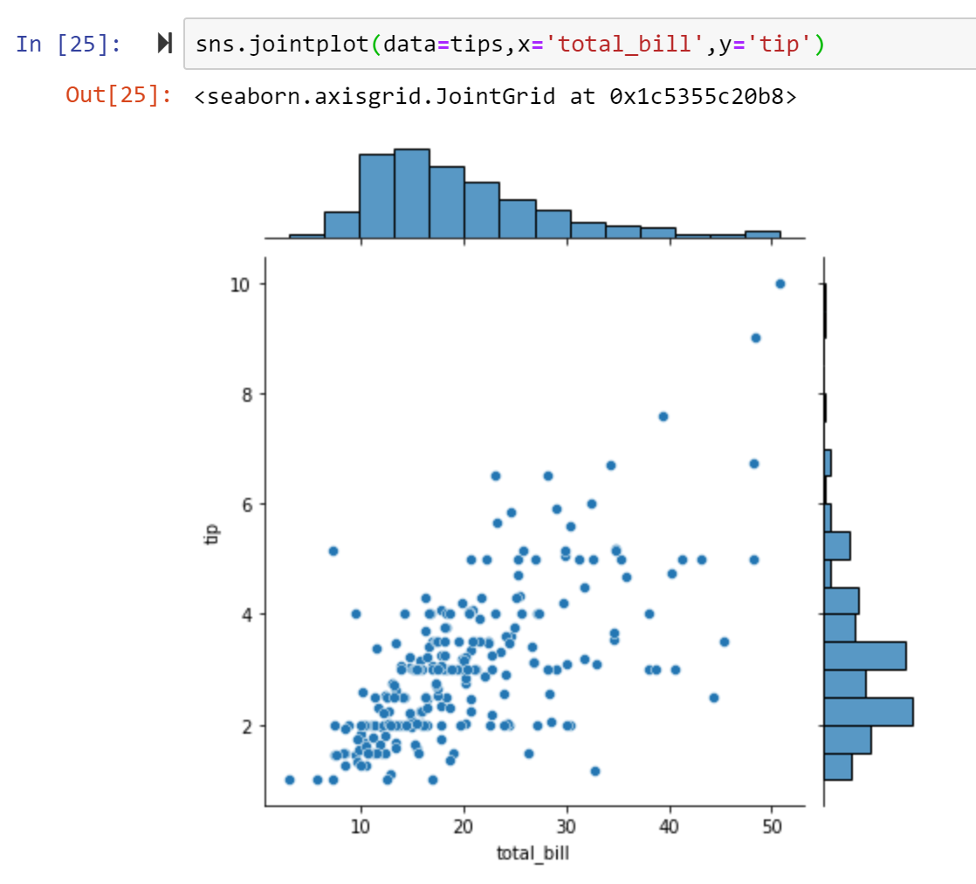

By default, jointplot() will display the bivariate distribution, using scatterplot(), and the marginal distribution, using histplot(). You can change the scatter chart to another type:

***Figure 174: Changing plot type in the joint distribution plot***

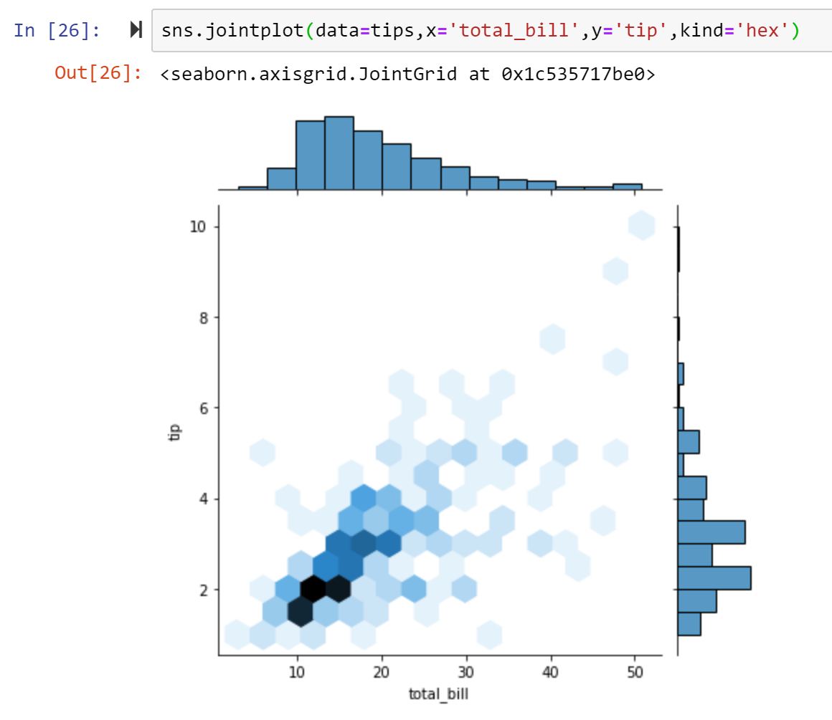

Instead of using jointplot(), you can use JointGrid() to have more flexibility to add any plots you want to the joint distribution plot. For example:

***Figure 175: Creating a joint distribution using the JointGrid() method***

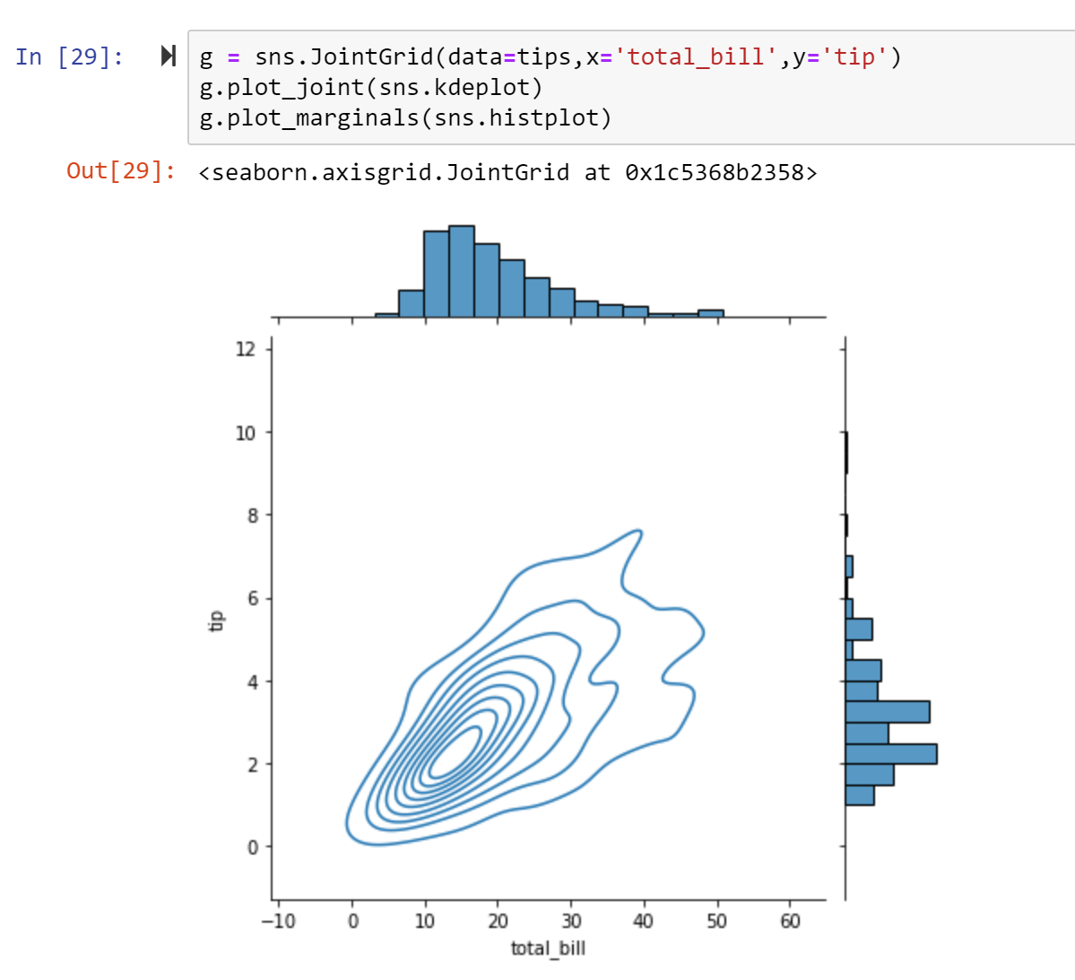

In a lot of cases, it’s useful to visualise the data to understand the relationship between variables in the dataset. In *Seaborn*, relplot() is commonly used and it’s figure-level functions as we mentioned before. Alternatively you can use scatterplot() and lineplot() which are axes-level functions. **Figure 176** demonstrates the relplot() method, while **Figure 177** demonstrates the scatterplot() method.

***Figure 176: Creating a scatter plot using the relplot() method***

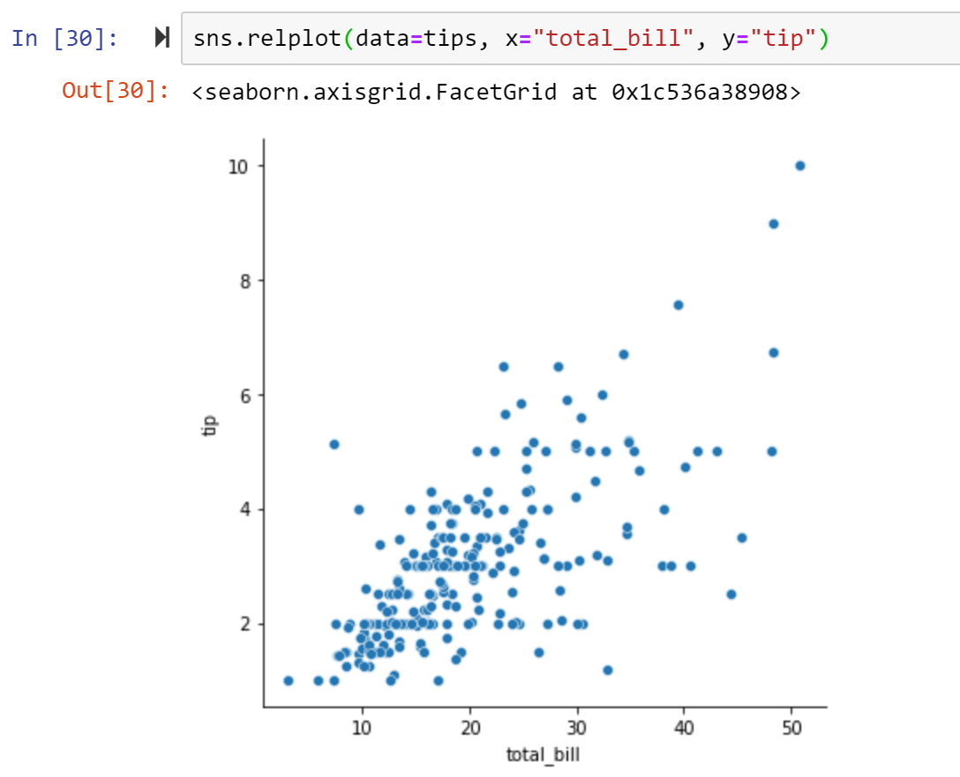

***Figure 177: Creating a scatter plot using the scatterplot() method***

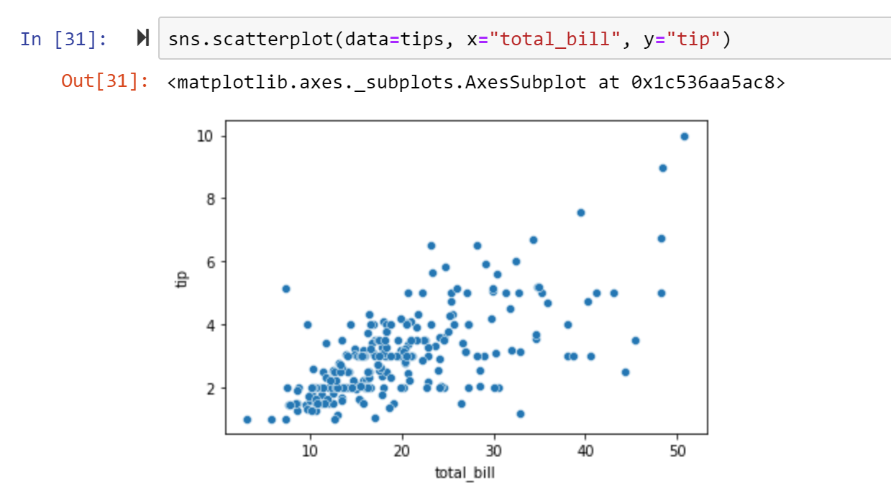

As with distribution plotting, you can assign hue and/or style to add more dimension to the plot. For example:

***Figure 178: Assigning hue and style to a scatter plot***

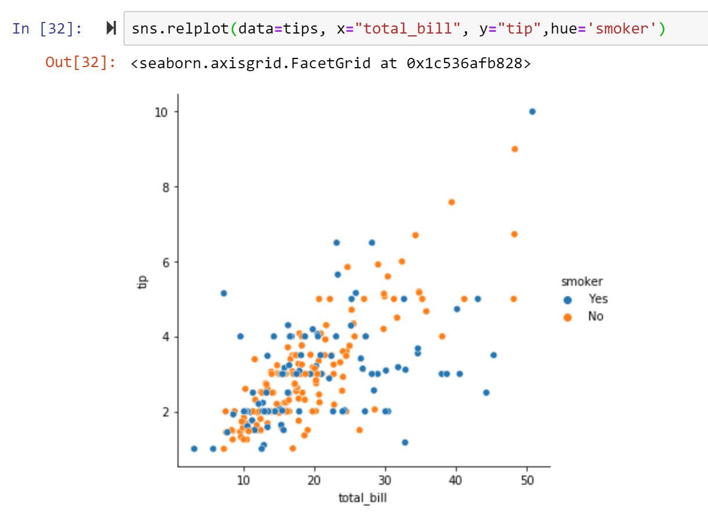

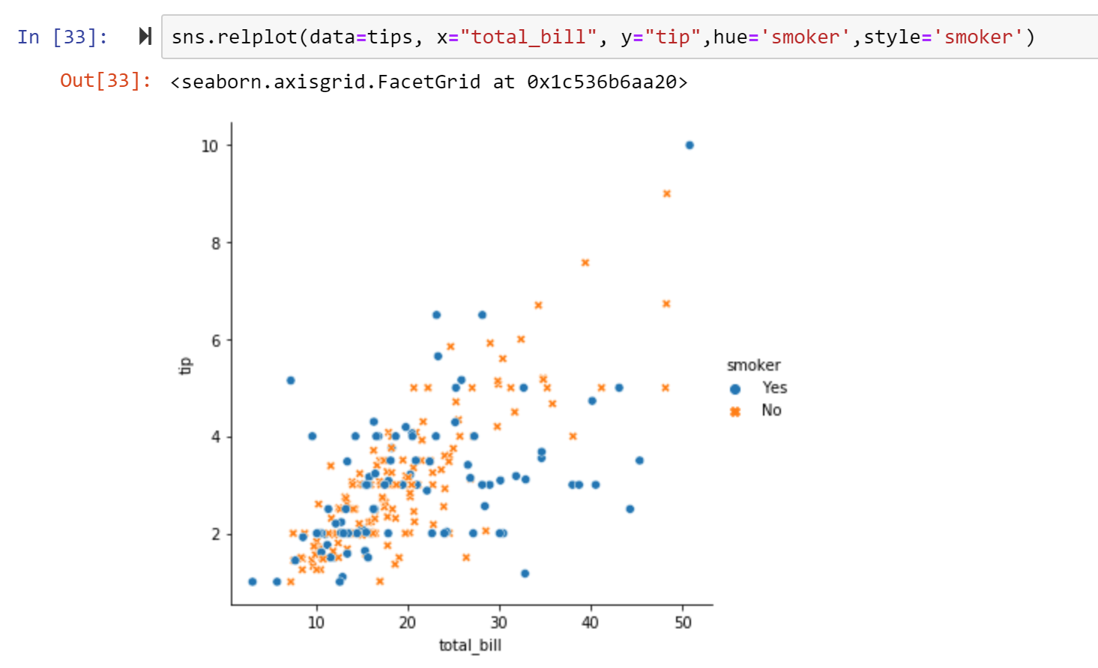

A scatter plot can be very effective to check the relationship between two variables. However, if you want to understand the changes in a variable caused by time or another similarly continuous variable, a line plot would be more suited. Here we can see the tips dataset by different days of the week by via a line chart. You can use either relplot() with kind=’line’ or lineplot():

***Figure 179: Creating a line chart using relplot() anf lineplot() methods***

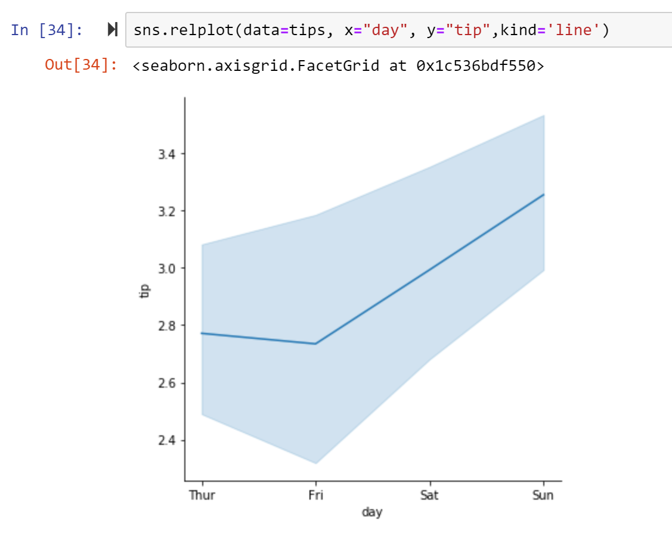

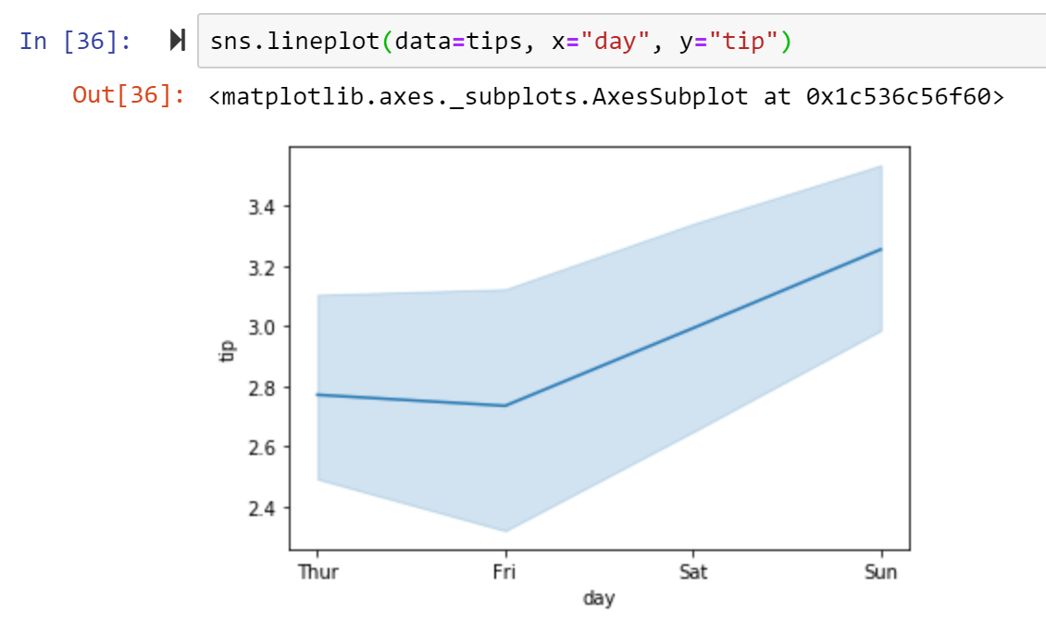

Similarly, you can set up hue or style for your line chart as we do for the scatter plot and distribution plot. You can also create multiple plots to show the multiple relationships by using relplot(). In this way, you can incorporate more information into your visualisation:

***Figure 180: Multiple relational plots***

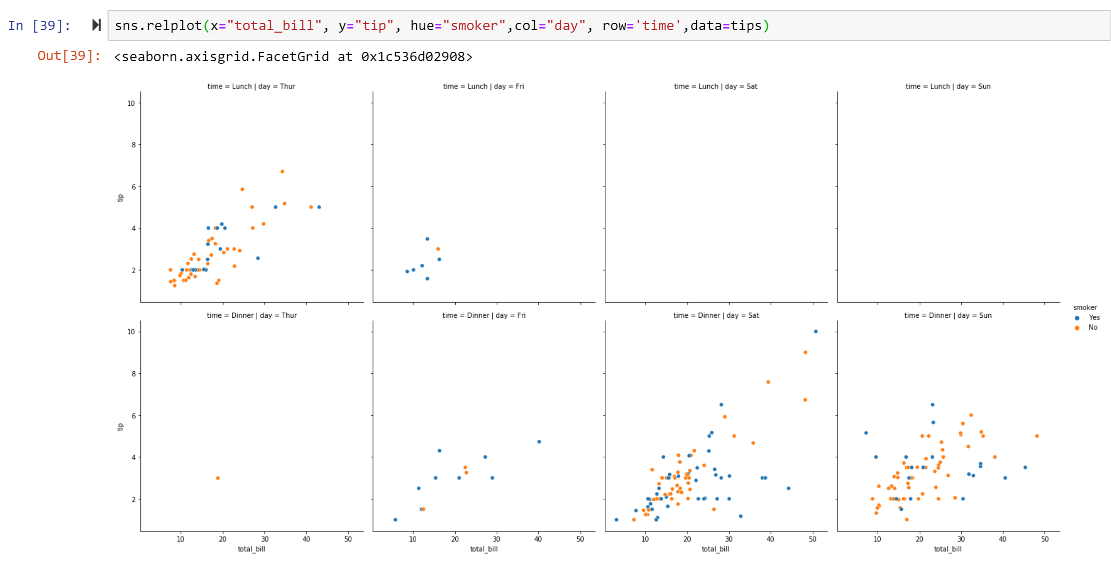

In the scatter plot, we can see the ‘total bill’ and ‘tips’ have potential relationship. To show this in a more direct way, we can build a regression model (as we did in chapter five) and visualise this using regplot() or lmplot(), both of which are functions used to draw linear regression plots. Both draw a scatterplot of two variables x and y, and then fit the regression model y ~ x, plotting the regression line and a 95% confidence interval. Here are the examples:

***Figure 181: Creating regression plots using the regplot() and lmplot() methods***

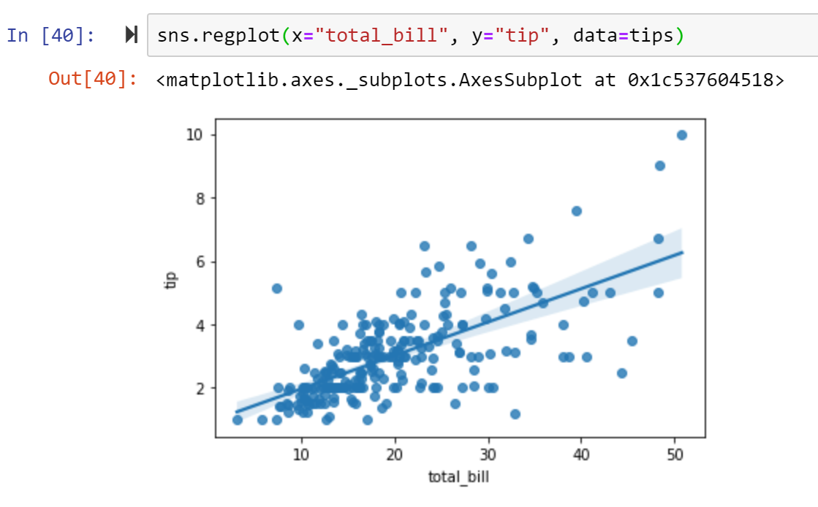

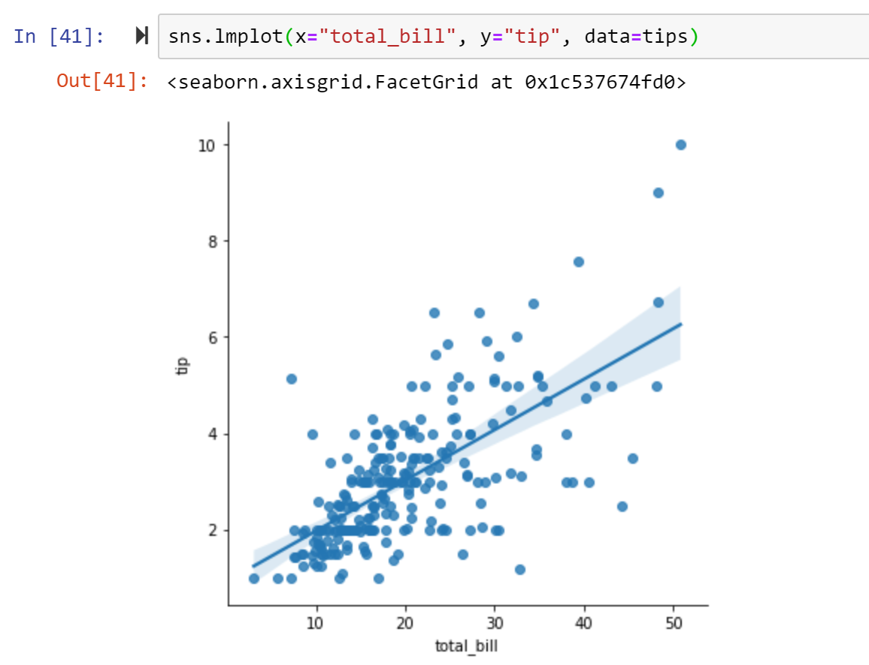

You can see here the results from both functions are almost the same. But they have slight difference. Basically, regplot() performs a simple linear regression model fit and plot. lmplot() combines regplot() and FacetGrid. The FacetGrid class helps visualise the distribution of one variable as well as the relationship between multiple variables separately within subsets of your dataset using multiple panels. Thus, lmplot() is more computationally intensive and is intended as a convenient interface to show a linear regression on “faceted” plots that allow you to explore interactions with up to three categorical variables. For example:

***Figure 182: Showing regression on facet plots using lmplot()***

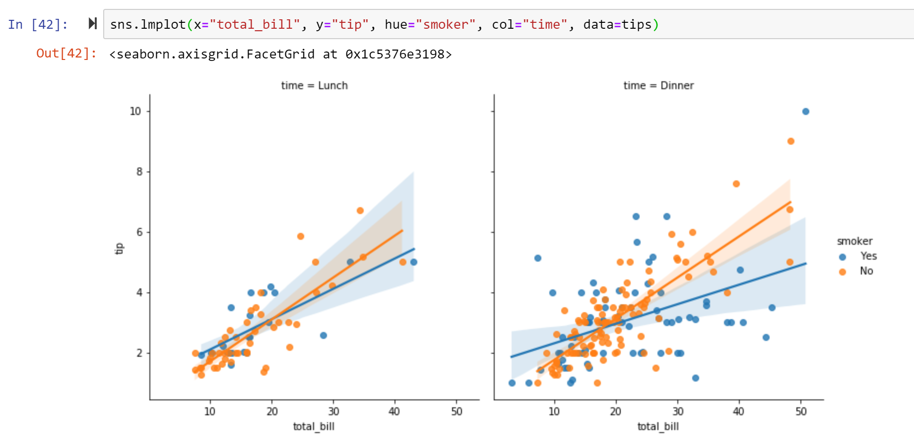

You can also use jointplot() in this case to join the regression plot and the distribution plot as what we mentioned in the distribution module:

***Figure 183: Joining a regression plot with a distribution plot***

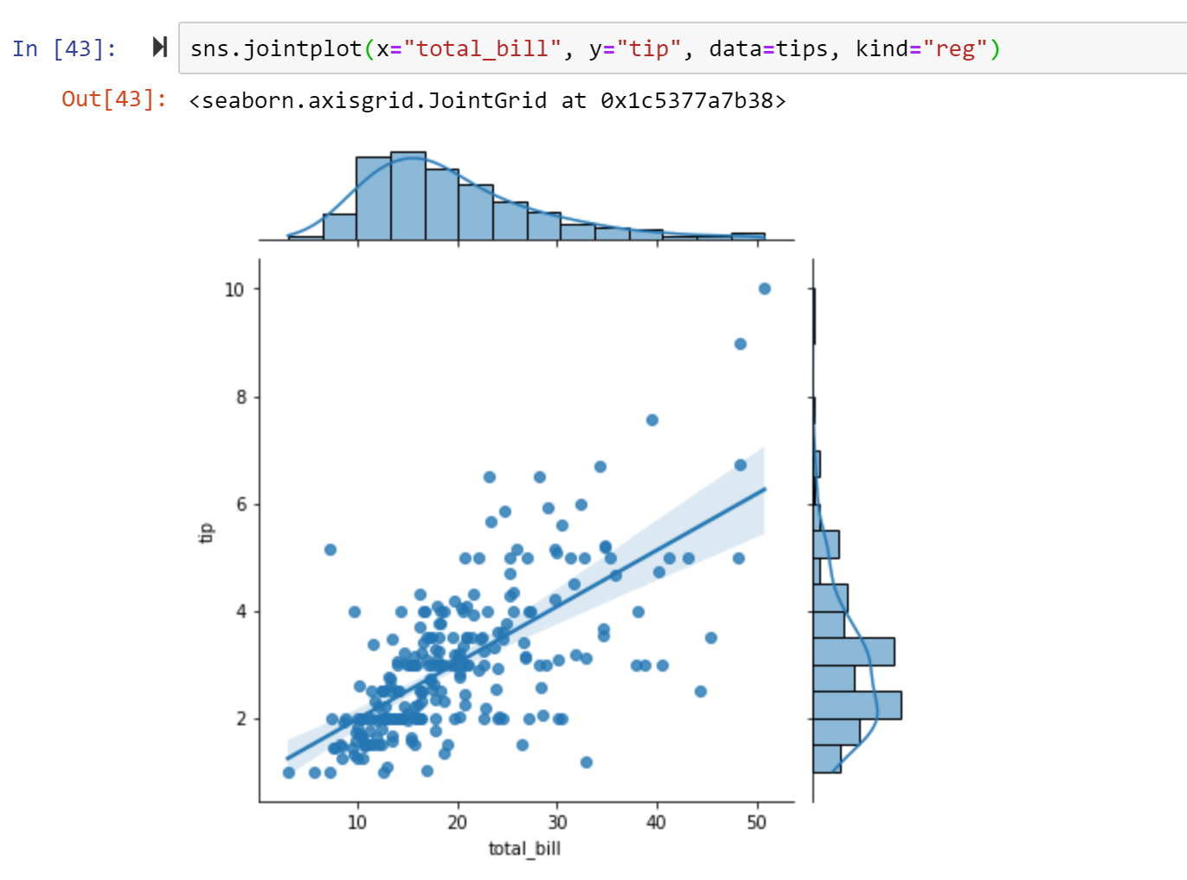

If the main variable is categorical, then categorical functions would be useful to visualise categorical data. Generally, there are three kinds of categorical plots that are available in seaborn, which includes categorical scatter plots (stripplot() and swamplot()), categorical distribution plots (boxplot(), violinplot(), boxenplot()) and categorical estimate plots (pointplot(), barplot(), countplot()). All this plots can be replaced as catplot() which is figure-level functions similar to relplot() and displot(). Next, we will give some examples in each type of categorical plots.

Categorical scatterplots include strip plot and swarm plot. The default representation of the data in catplot() uses a stripplot. Therefore, we can use catplot() to draw strip plot directly or use catplot() by assigning kind=’swarm’ to draw swarm scatter plot. Optionally, we can use stripplot() or swarmplot() instead.

The stripplot() will draw a scatterplot where one variable is categorical. A strip plot can be drawn on its own, but it is also a good complement to a box or violin plot in cases where you want to show all observations along with some representation of the underlying distribution.

The swarmplot() is similar to stripplot(), but the points are adjusted (only along the categorical axis) so that they don’t overlap. This gives a better representation of the distribution of values, although it does not scale as well to large numbers of observations (both in terms of the ability to show all the points and in terms of the computation needed to arrange them).

***Figure 184: Creating strip plot using catplot() method***

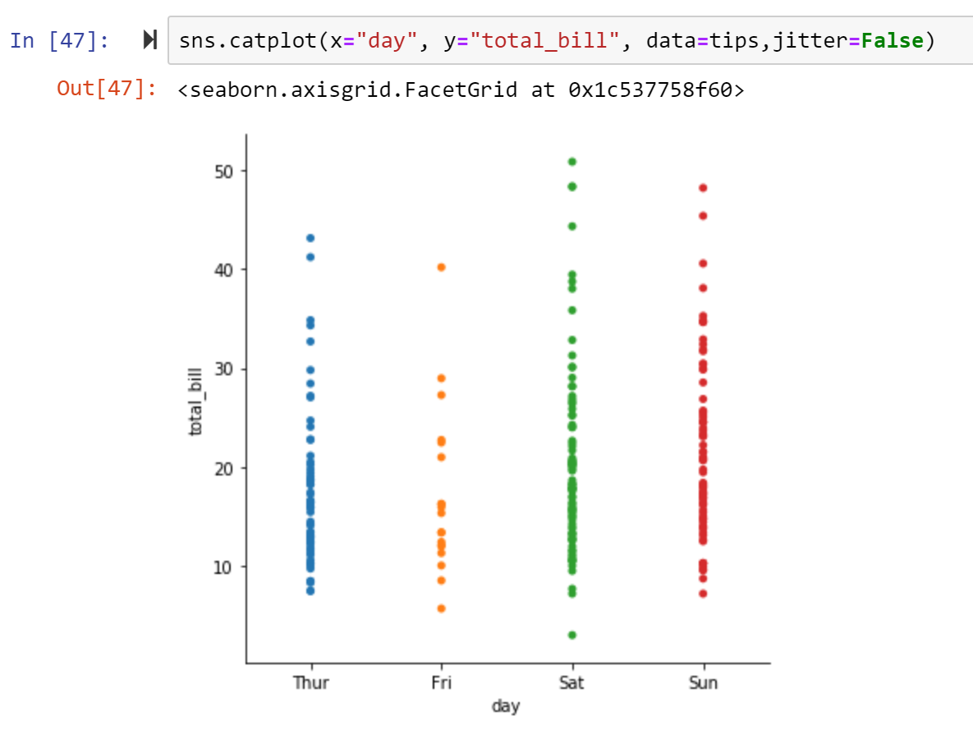

***Figure 185: Creating swarm plot using catplot() method***

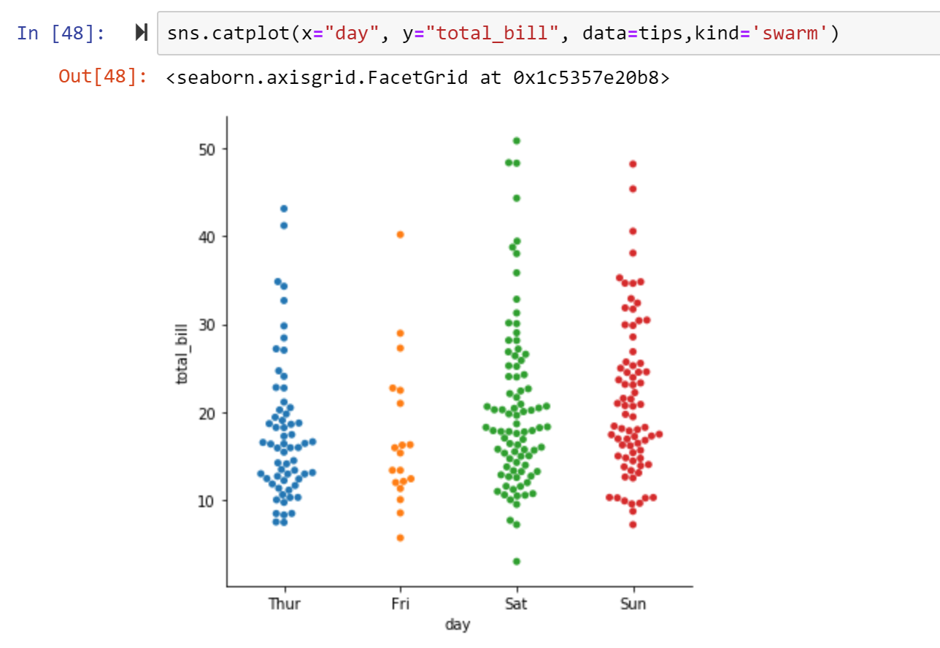

Like a relational plot and distribution plot, you can assign hue to the categorical scatter plot to have more dimensions in the chart. When using displot(), histplot() or kdeplot(), we usually draw the univariate or bivariate distributions. But if we want to compare the distributions among different “categories”, then categorical distribution plots will be more informative. The commonly used categorical distribution plots are boxplot and violin plot. To draw boxplot and violin plot, you can either using catplot() by setting the kind or using boxplot() and violinplot() respectively. Here are the examples using the same dataset:

***Figure 186: Creating boxplot using catplot() method***

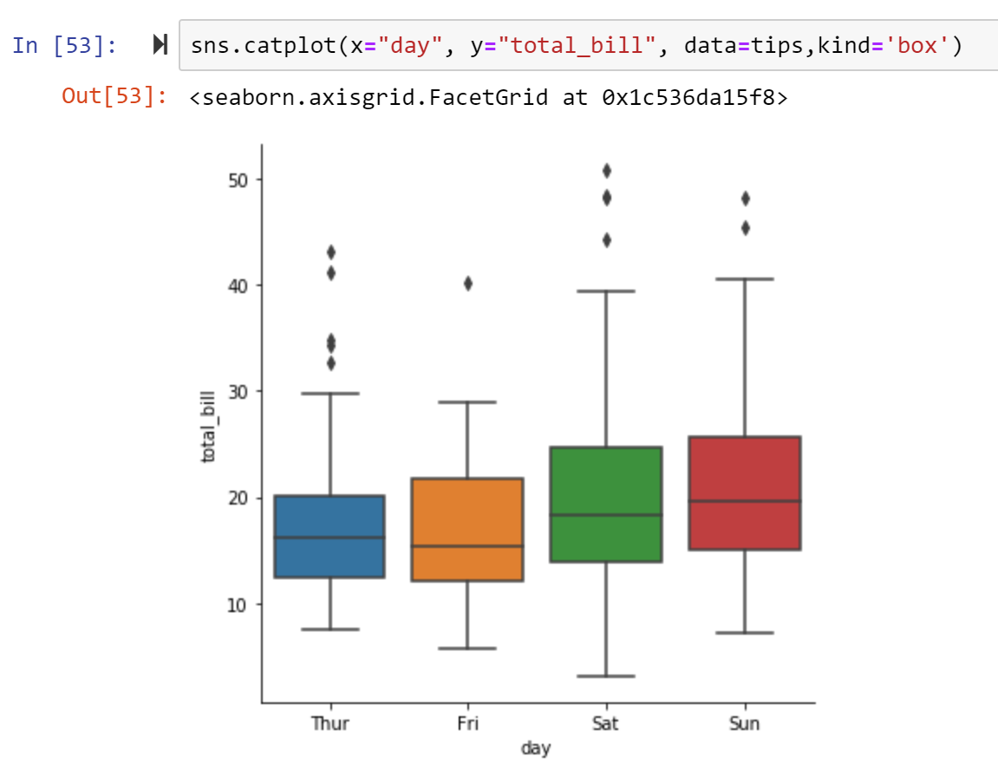

***Figure 187: Creating violin plot using catplot() method***

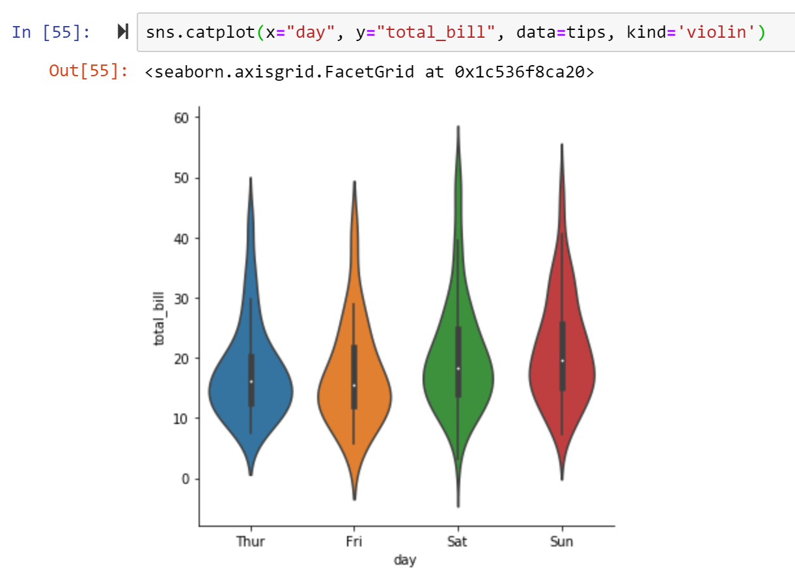

You can also visualise the distribution of all the columns (with numerical data) in the dataset (if you want a vertical view of the data) by using orient=’h’ assignment:

***Figure 188: Drawing a boxplot for the whole dataset***

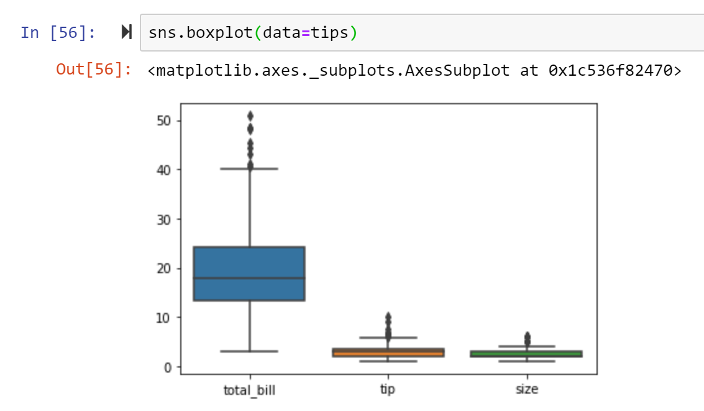

Rather than showing distribution of the data, you might want to show an estimate of the central tendency of the value (e.g. sum, mean etc.) The most common plot type for this purpose is bar plot or count plot (bar plot showing counts of the observation) in *Seaborn*. Similar to the other categorical plots, we can use either figure-level function (sns.catplot() with kind=’bar’ or sns.barplot()/sns.countplot()). Below are some examples using the same dataset, but now focusing on the amount of bill from customers of different gender.

***Figure 189: Creating bar chart using barplot() method***

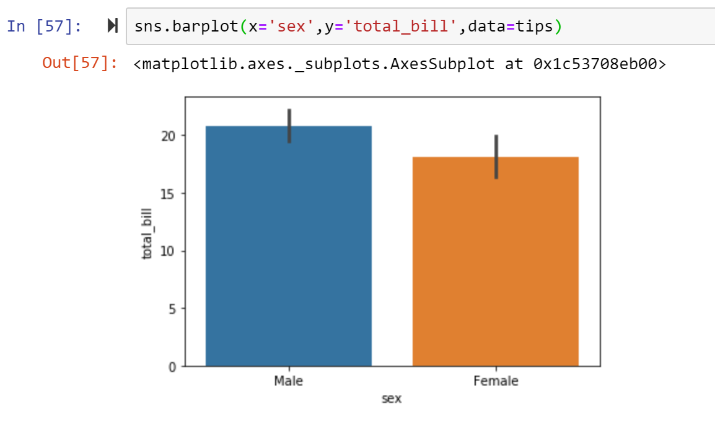

When there are multiple observations in each category, it also uses bootstrapping to compute a confidence interval around the estimate, which is plotted using error bars. And by default, the estimate takes the mean of each category. So here the chart shows the average amount of bill for each gender. If you want to change the mean to the sum or any other estimator, you can assign estimator to change (the estimator can be assigned with any statistical function to estimate within each categorical bin and you can import *NumPy* to do that):

***Figure 190: Changing the estimator for the bar chart***

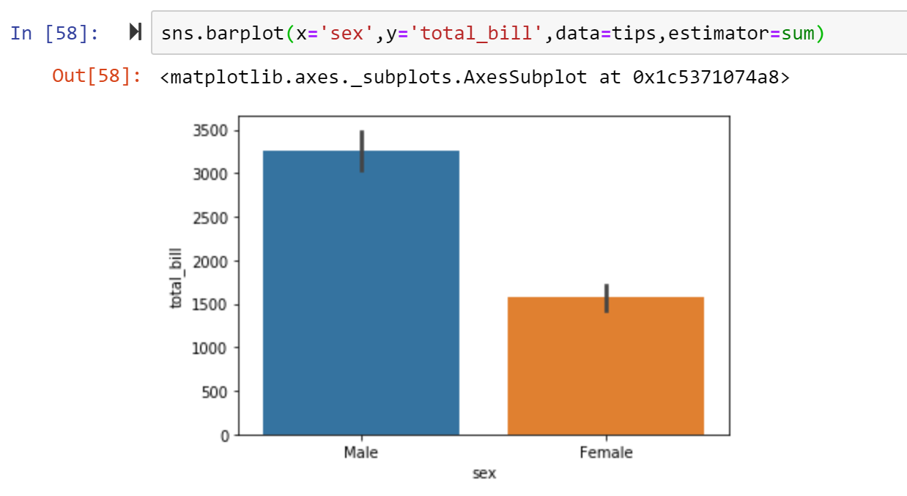

And as we mentioned, the error bar shows the confidence interval (by default ci=95) and you can remove it, adjust it, or change it to standard deviation (ci=’sd’) as you want:

***Figure 191: Adjust the confidence interval to 70% on a bar chart***

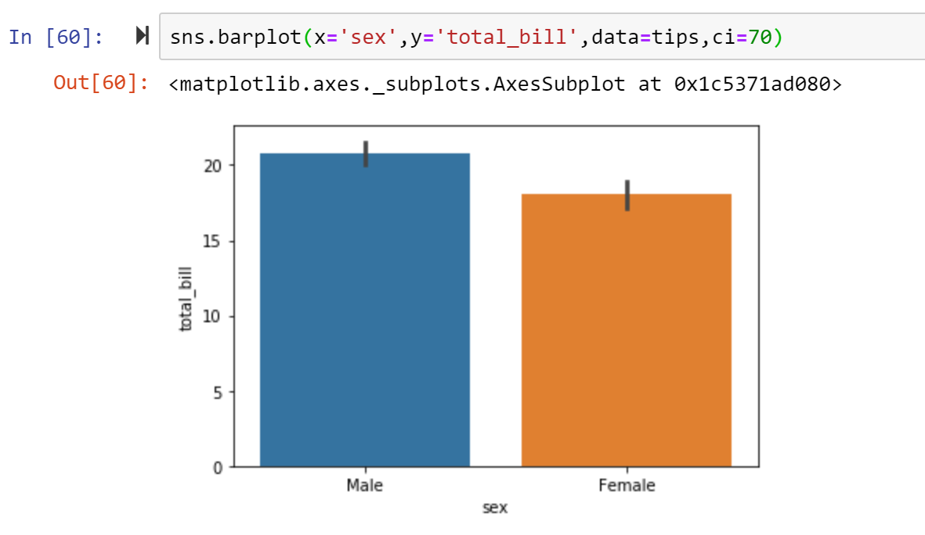

***Figure 192: Adjust the confidence interval to standard deviation on a bar chart***

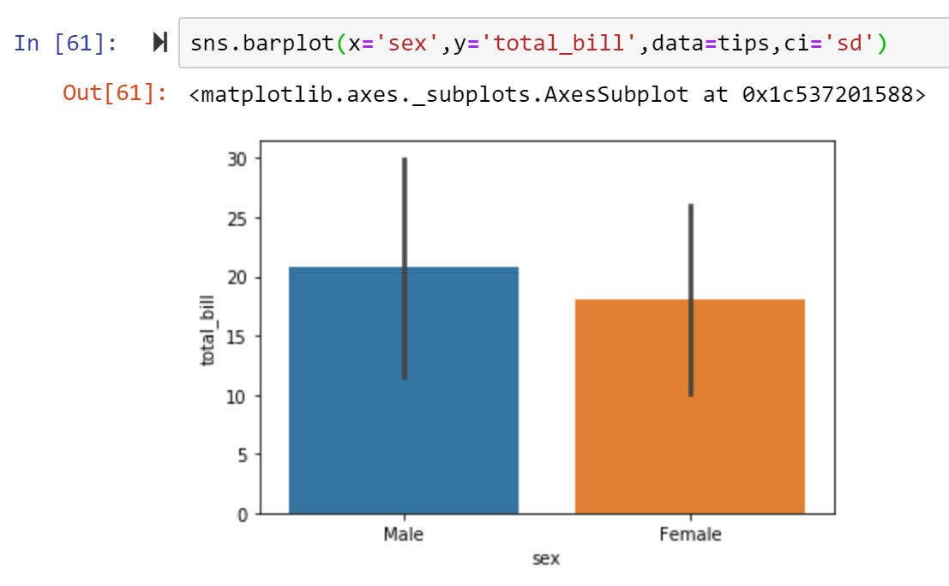

Like other plots, you can set up hue for your bar chart to create a clustered column bar chart (by default) or stacked bar chart (dodge=False) when assigning hue:

***Figure 193: Assigning hue to the bar chart***

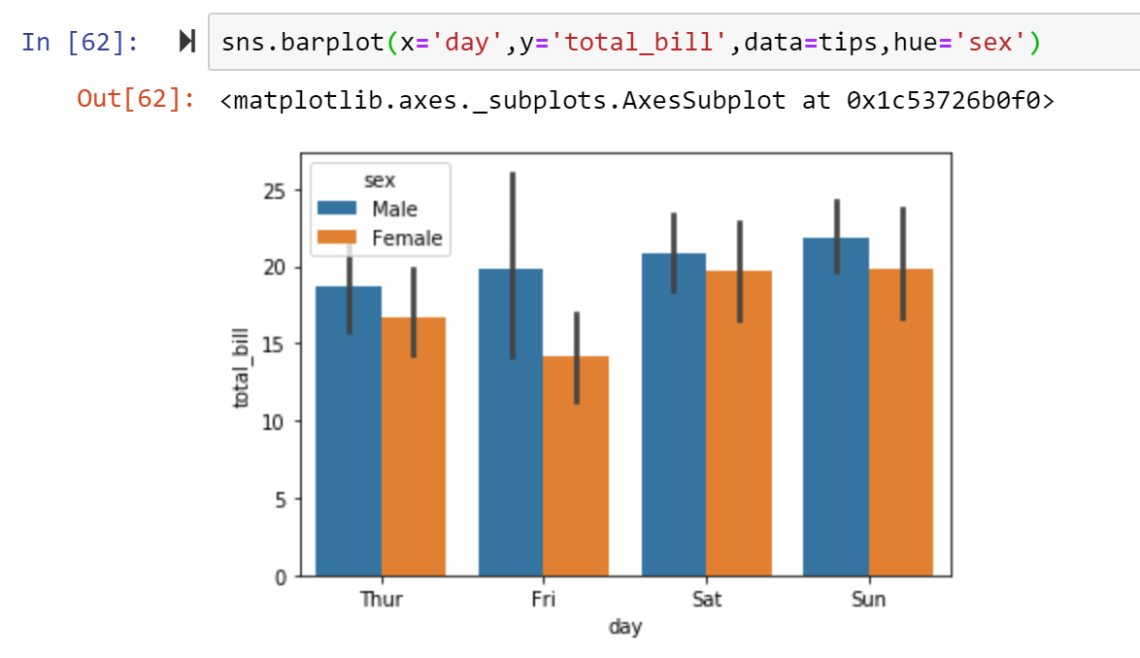

If you just want to show the number of the observations instead you can use countplot() as a special case for bar chart.

***Figure 194: Creating a count plot using countplot() method***

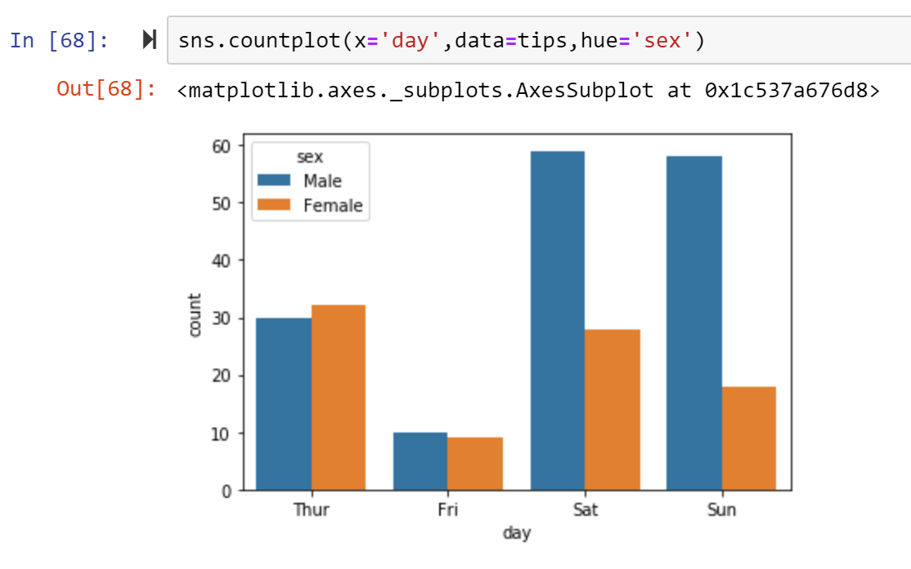

As with other categorial plots, you can also use catplot() as a good way for you to create facet grid that allowing you to create multiple plots:

***Figure 195: Creating bar plot using catplot() method***

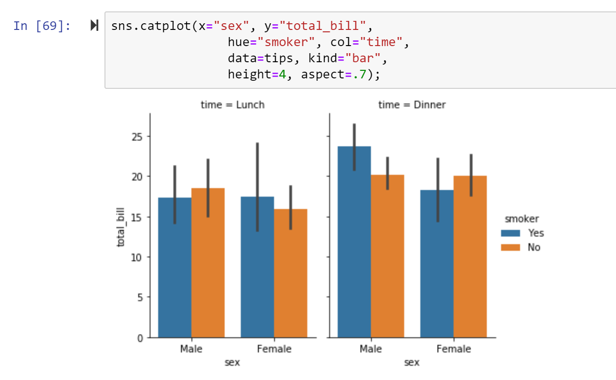

The above are the most commonly used charts/graphs that you can employ using *Seaborn*. Many are ultimately similar in terms of their coding. In the last part of this section, we will cover some examples of the visualisation of both grids and matrices.

* 1. **Facet Grids and Matrix Plots in *Seaborn***

We have covered in the previous section primarily figure-level functions and jointplot. Here we will introduce another function called FacetGrid, which will also create multiple plots.

***Figure 196: Creating multiple plots with FacetGrid()***

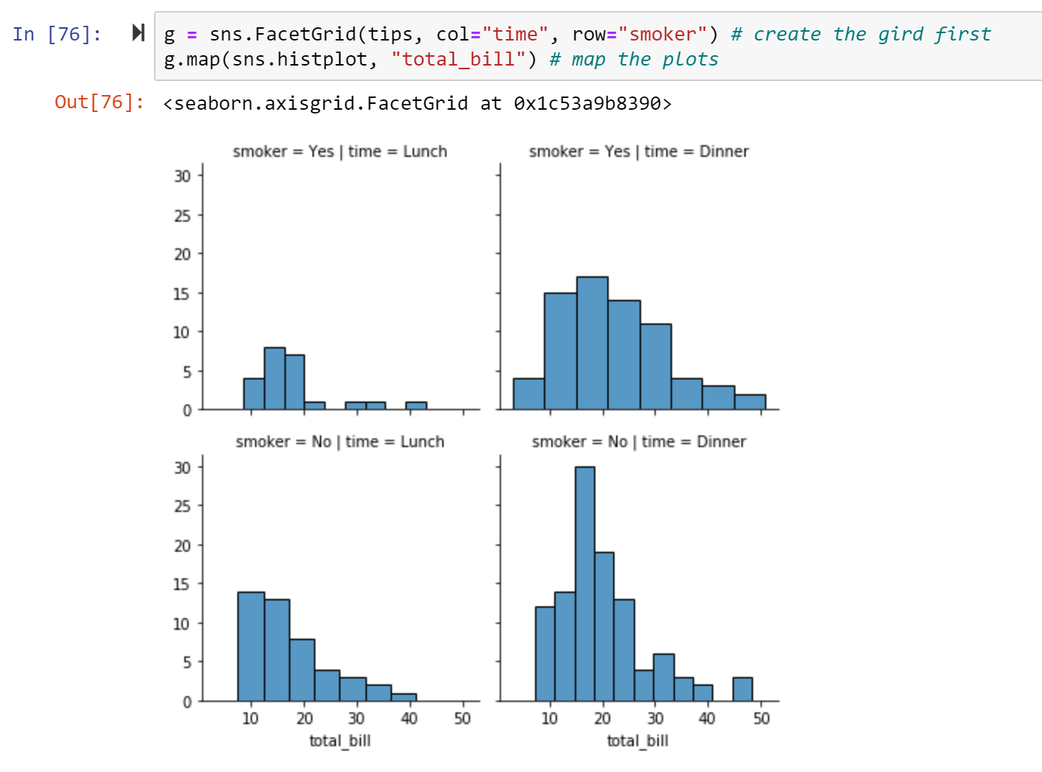

There is also some other gird visualisation like pair grid plots in *Seaborn*, but we are not going to cover here. You can explore the web page if you are interested in this: <https://seaborn.pydata.org/tutorial/axis_grids.html>.

Next, we will see how we can visualise matrix plots such as heatmaps in *Seaborn*. We didn’t cover this kind of plots in *Matplotlib* and *Pandas* because using seaborn would be much easier. Here is the example to create a heatmap in *Seaborn*:

***Figure 197: Creating a heatmap in Seaborn***

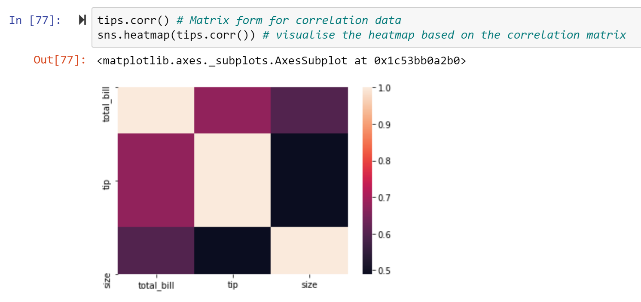

You can set up colour and annotation for your heatmap to make it more informative by adding argument:

***Figure 198: Setting colours and annotations for our heatmap***

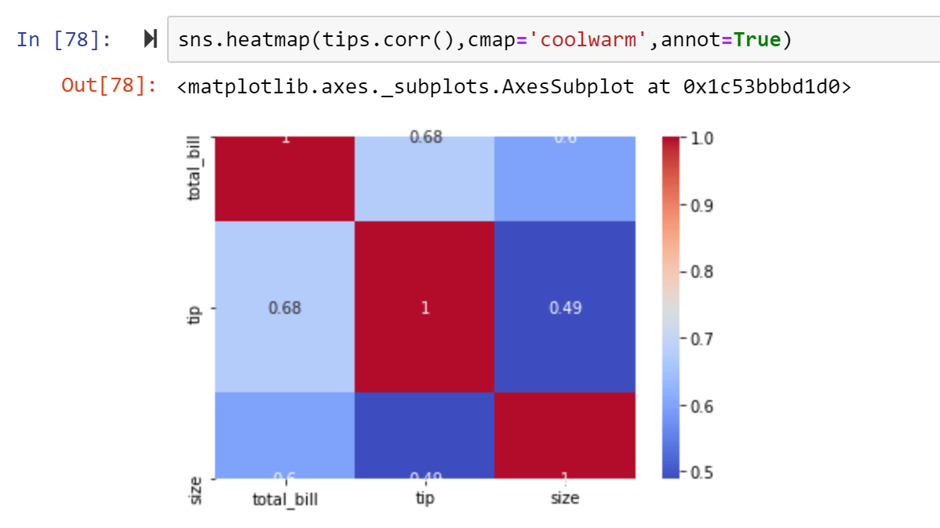

You may notice that the heatmap is not displayed properly as the first and last row is obscured. We can fix it by adjusting the y axis limit to make it better. You can check the original ylim values and then set the new one:

***Figure 199: Adjusting the size of the heatmap***

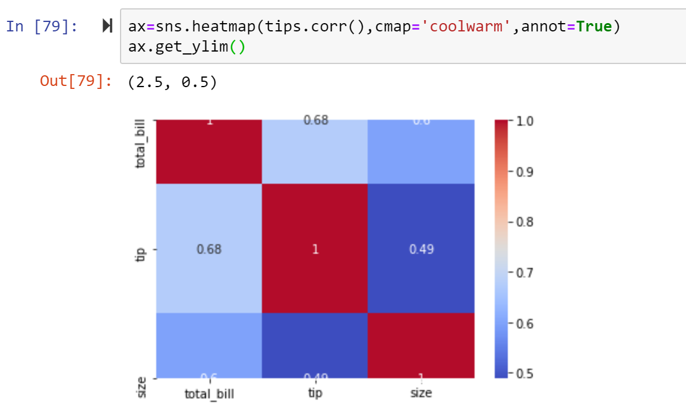

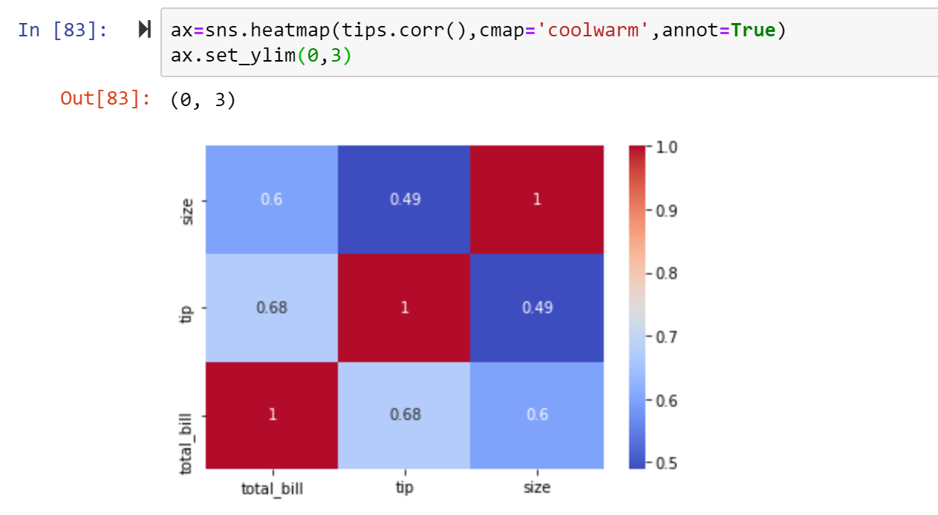

Before creating charts, we can set modify the theme. Check out <https://seaborn.pydata.org/generated/seaborn.set_theme.html> to understand how you can set the parameters. Alternatively you can use the sns.set_style() method to set the aesthetic style of the plots. For “Style” can choose None or one of darkgrid, whitegrid, dark, white or ticks. Here we will stick with the default theme.

# Apply the default theme

sns.set_theme()

or

sns.set_style(‘whitegrid’)

When you are doing your plotting, you can adjust your plots as you want. The customising can be done through the argument set for each function and you can take a look at the documentation to understand how you can assign the relevant keyword arguments. In addition, you can do this through *Matplotlib*. You can create the figure and axes and then set the parameters as we covered in the *Matplotlib* section. For the aesthetic requirement especially the colour palettes, please check [https://seaborn.pydata.org/tutorial.html#](https://seaborn.pydata.org/tutorial.html) to see what are available for you to choose.

* 1. **Summary**

To wrap up, we have covered three main ways of implementing visualisation in Python, all of which are underpinned by *Matplotlib*. Thus, I would recommend you learn *Matplotlib* first and then the other libraries are much easier to learn since they are sharing some APIs. In addition, this tutorial mostly covers the introductory content of each library by extracting some key aspects from the official library documentation. If you want to go deeper or create more complex visualisations, you can refer to the documentation or with more advanced tutorials from the official web pages. TL;DR the content here covers many of the most common applications, but as with anything you can go much deeper into this subject.